**AMAZON S3**

* Amazon S3 is **Simple Storage Service**.
* Amazon S3 is a web services interface that you can use to store and retrieve any amount of data at any period of time.
* Concepts:

1. Bucket: A bucket is basically a container which is used to store object in it.
2. Object: Object is a folder/folders inside the bucket and they consist of object data and metadata.
3. Key: A key is the unique identifier for an object within a bucket. Every object in a bucket has exactly one key.
4. Region: This is a geographic region where the Amazon S3 will store the bucket which you had created.

**Creating a S3 Bucket:**

* Go to the S3 Console and click on create bucket.
* Now give a **bucket name** and it must be unique if not it will show an error.
* In **Region** specify the region in which you want the bucket.
* In **Bucket settings for Block Public Access,** choose it as required.
* In **Default encryption,** it is recommended to keep it disable. Now create the bucket.

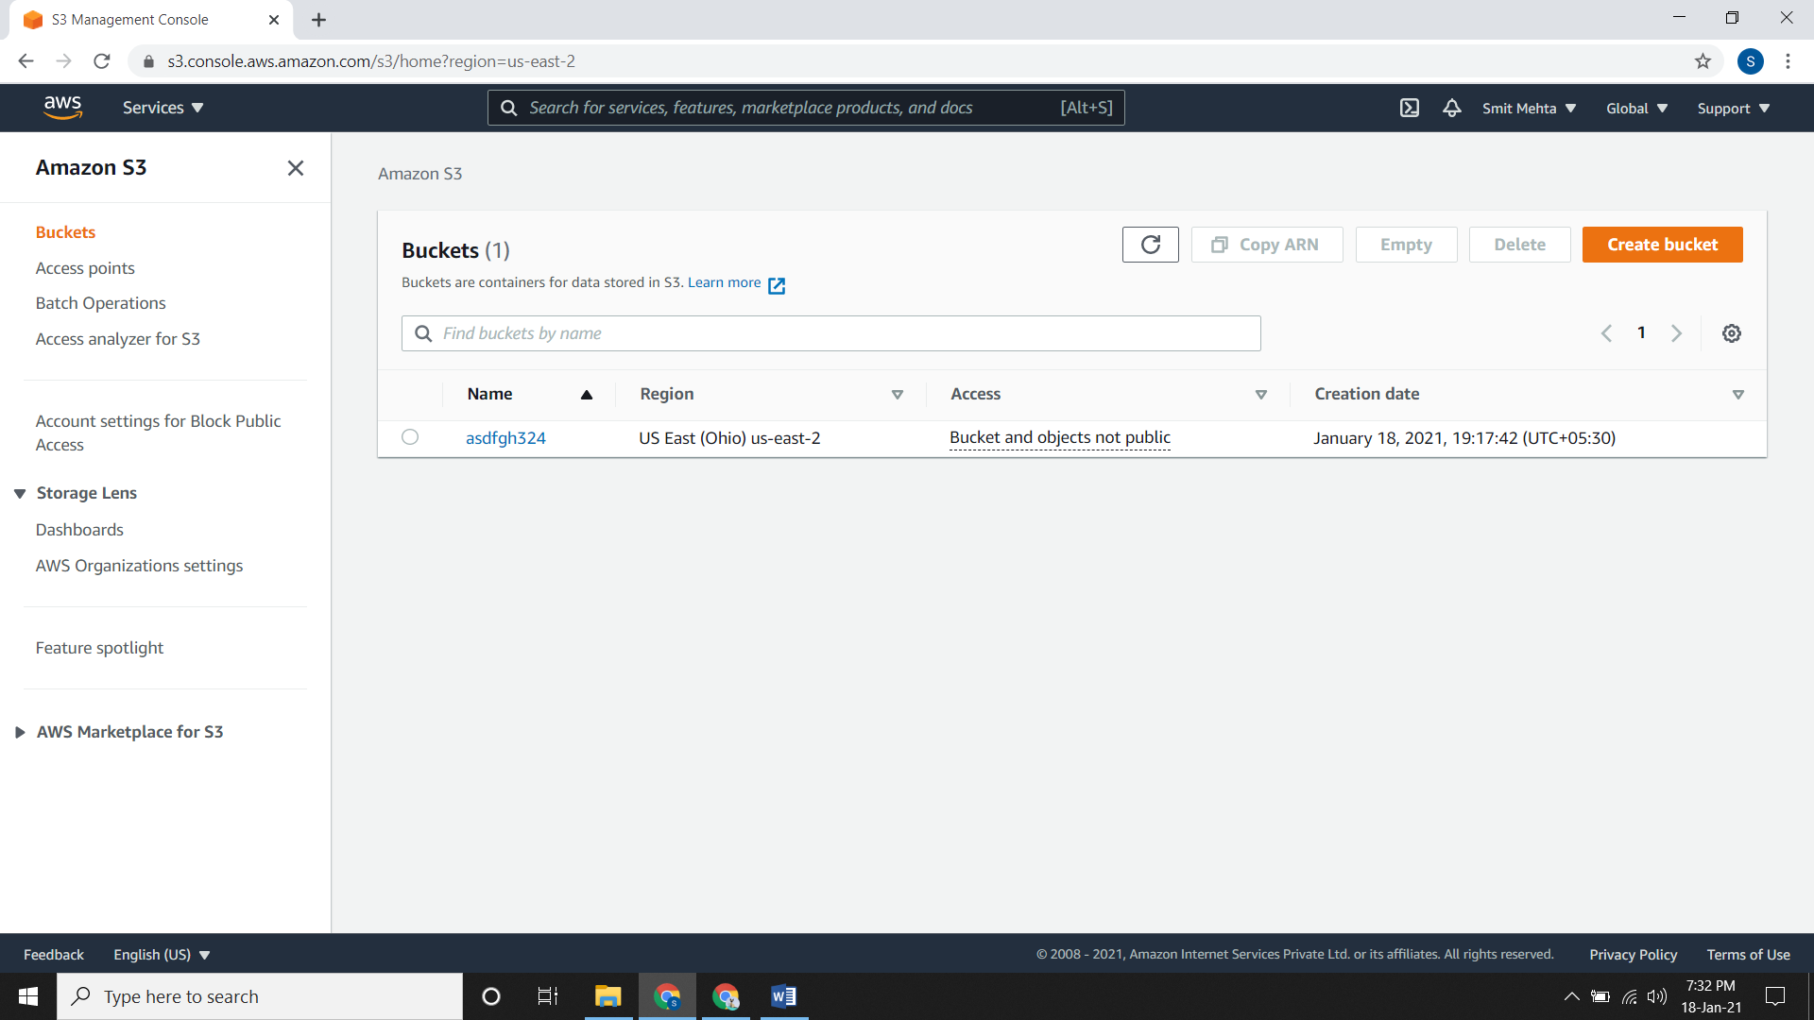

**Upload an Object to a Bucket:**

* Click on the **bucket name** where you want to upload an object.
* Now click on **upload** and **add a file**. Here you can create a folder and add files to it or else you can simply upload over here.
* Choose the file and upload it.

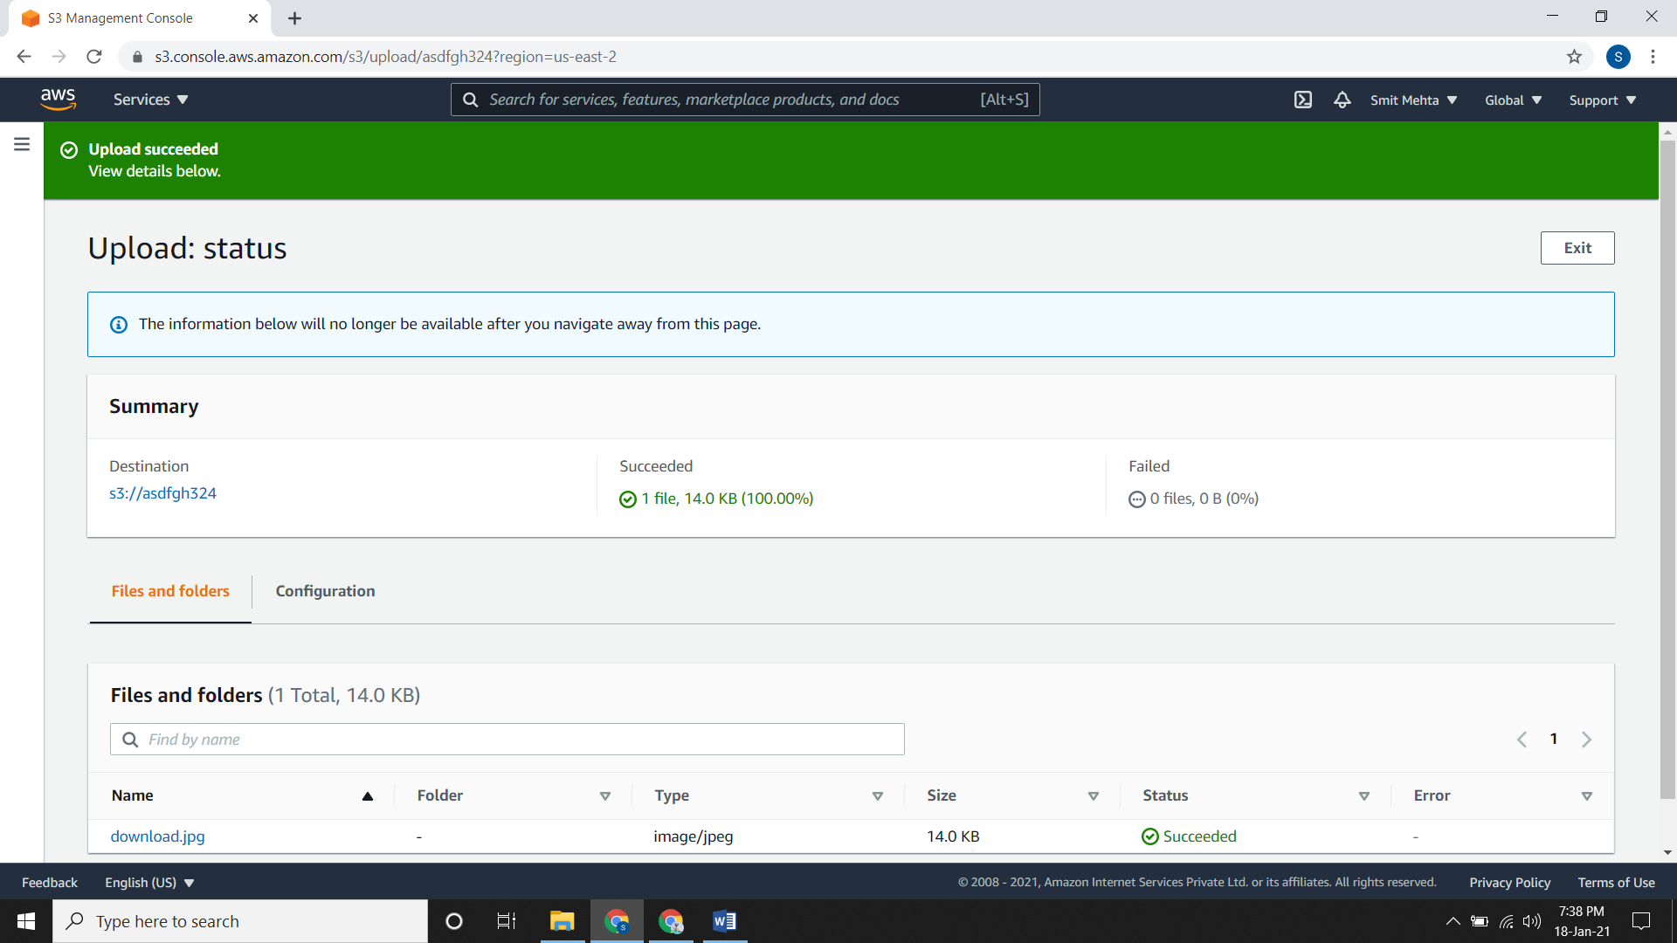

**Download an Object:**

* If you want to download any file, go to that bucket and the folder assigned to it and open it.
* Now choose that particular file and open it.
* A new tab will open and click on **Object Actions.** From here you can download it.

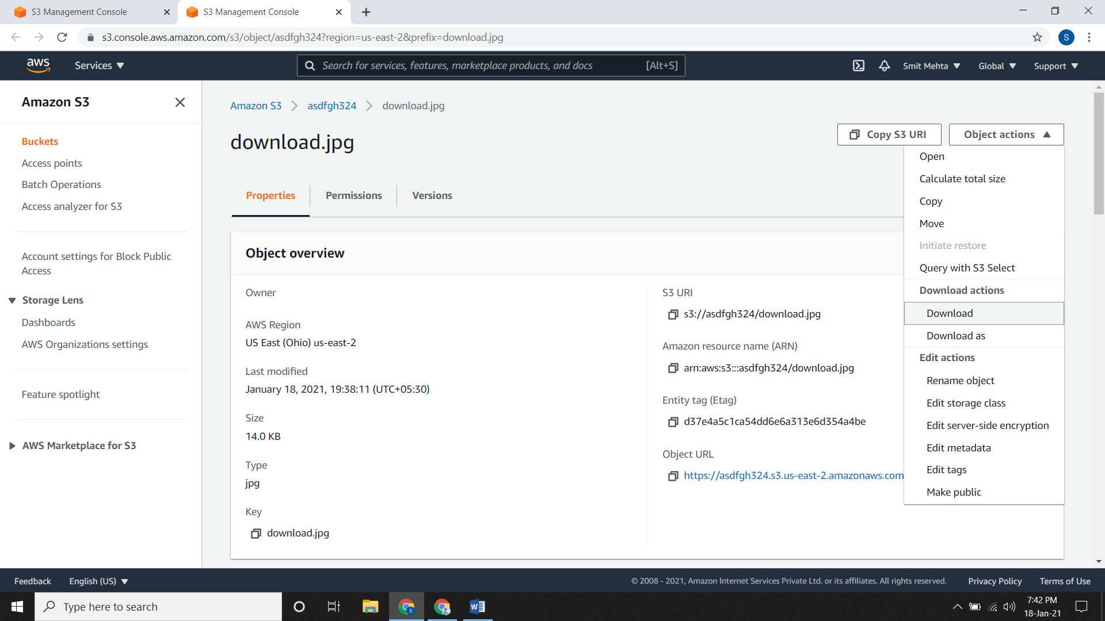

**Copy an Object:**

* Go the bucket and create a **folder**.

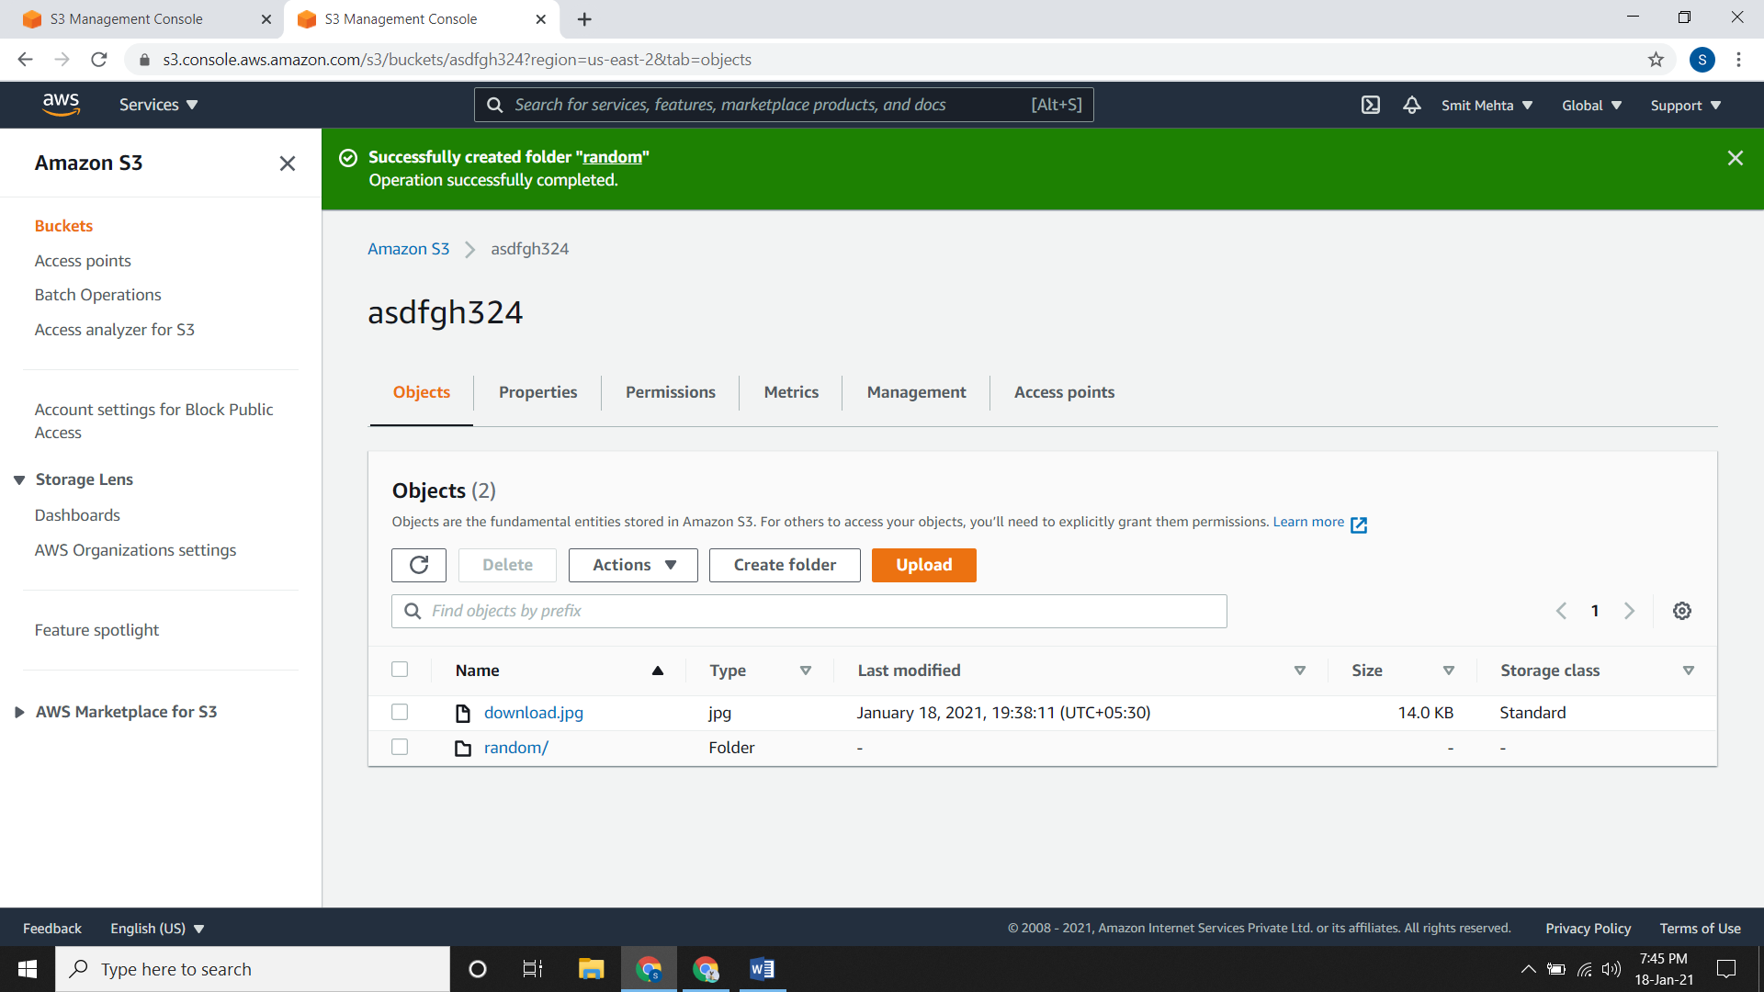

* Now go to file which you want to copy and open it. Click on **Object Actions** and **copy** it.
* In **Destination** click on **Browse S3**, now click on the folder and choose the destination.

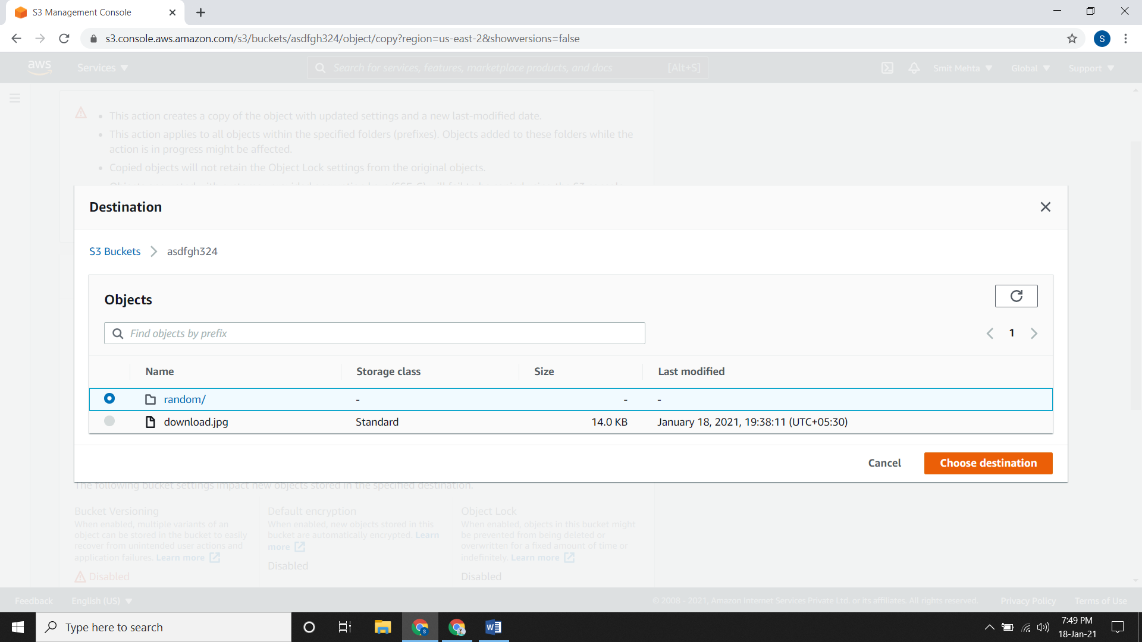

* Scroll down and click on copy the file will be copied to the destination point.

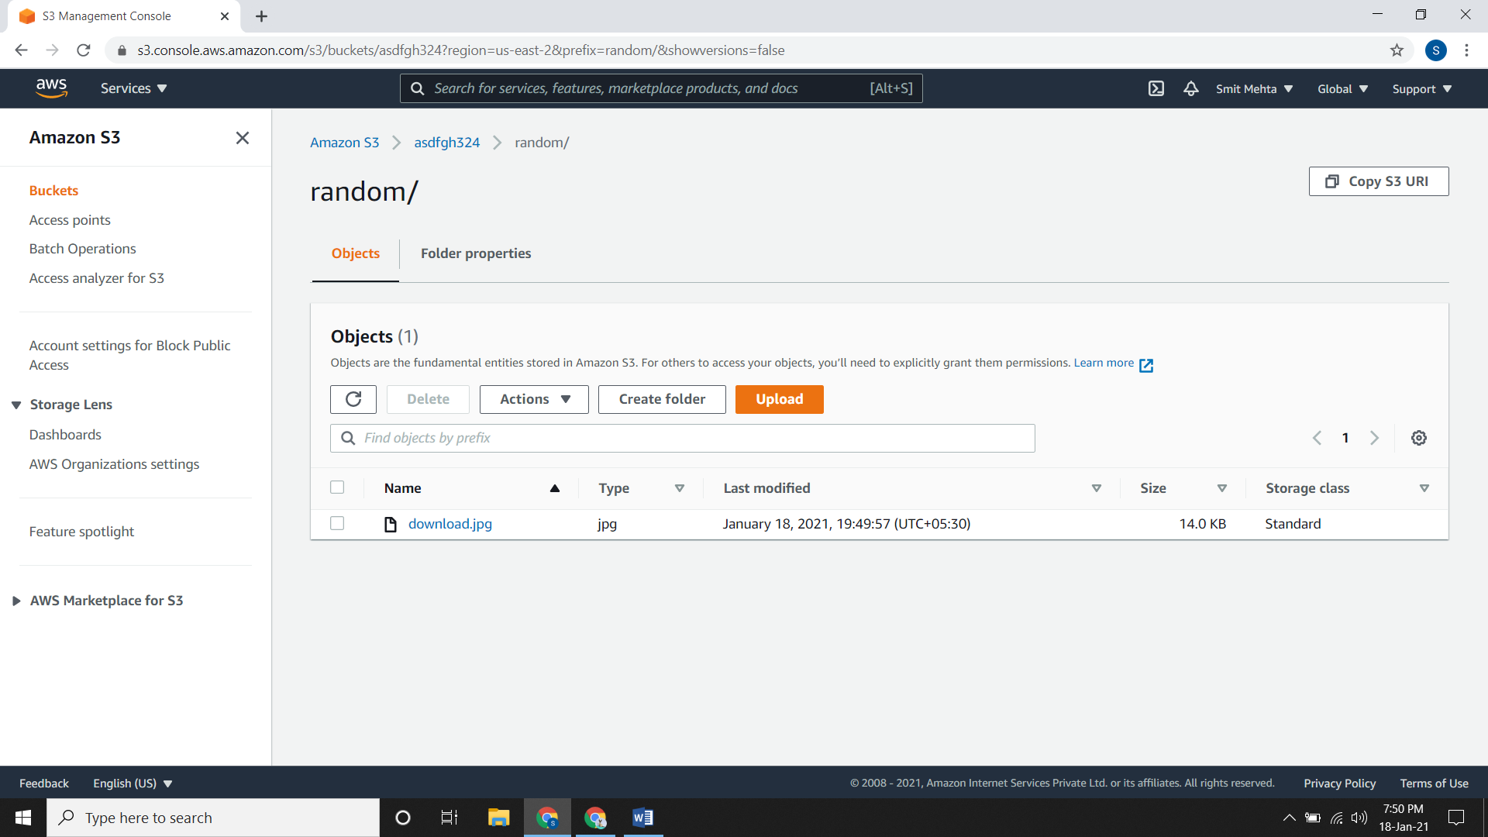

**Deleting your Bucket:**

* If you want to delete an object, click on the object and choose delete. After clicking on delete it will ask that if you want to delete this file permanently or not.
* After writing **permanently delete** click on **delete objects**.

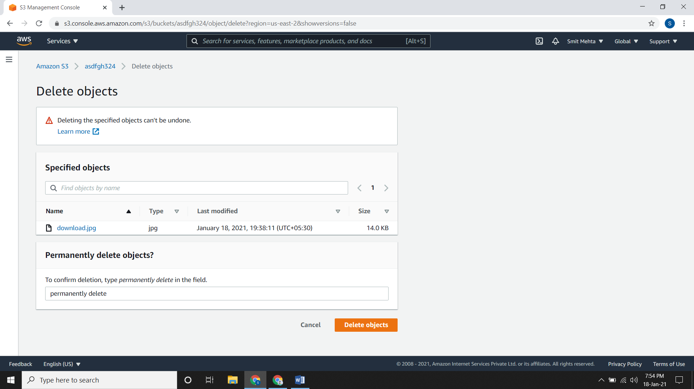

* If you want to delete the entire bucket you need to empty it first. For that click on the bucket and choose **empty.**

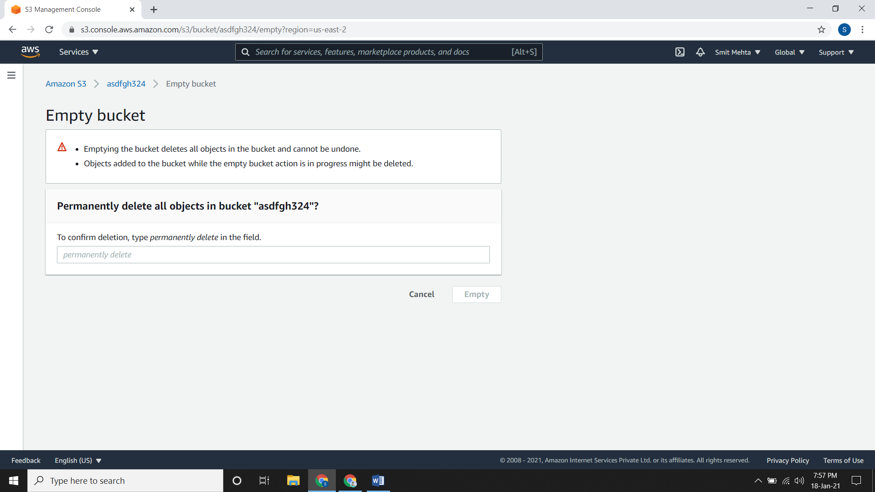

* After writing **permanently delete** click on **empty.**
* Now you can delete the entire bucket.
* So just click on the bucket and click **delete.**
* After writing the **bucket name** click on **delete bucket.**
* Now your bucket has been successfully deleted.

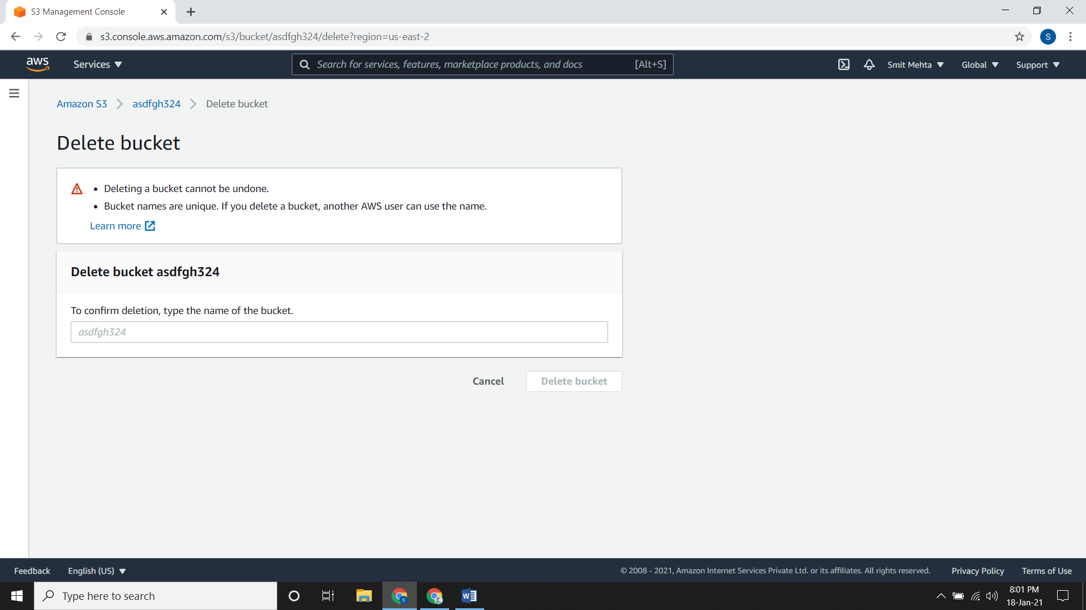

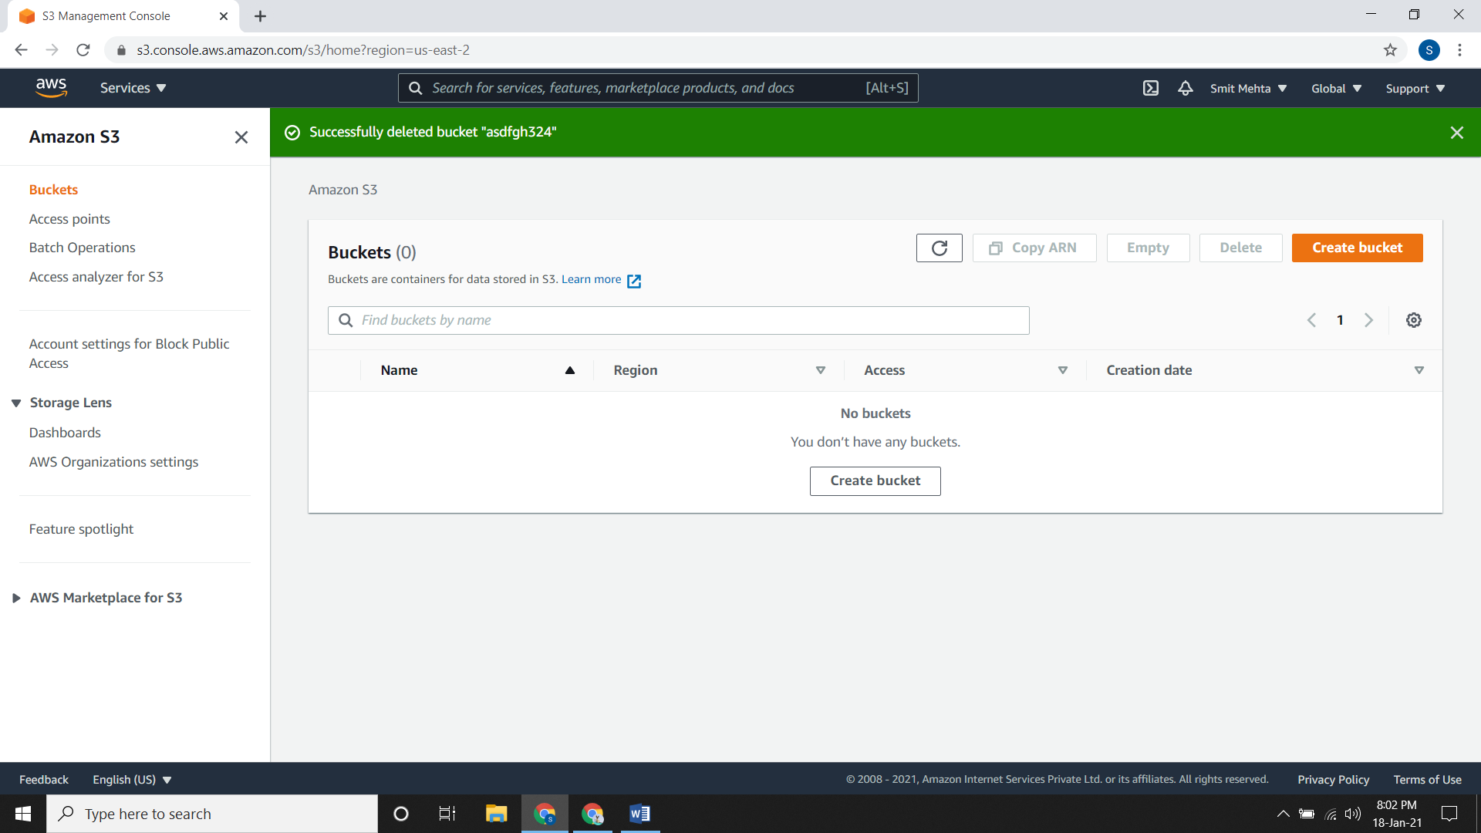

Amazon S3 Features:

1. **Storage Class**: Each object in S3 is associated with some type of storage class. There are various types of storage classes.

* Storage classes for frequently accessed objects: **S3 Standard.** This is the default storage class. If you do not assign a class, then by default it gets associated.
* Storage class for automatically optimizing data with changing or unknown access patterns: **S3 Intelligent-Tiering:** Without any operational overhead this storage class optimizes storage costs by automatically moving data to the most cost-effective access tier.
* Storage classes for infrequently accessed objects: **S3 Standard-IA & S3 One Zone-IA.** These storage class are designed for long-lived and infrequently accessed data and are available for milliseconds.
* Storage classes for archiving objects: **S3 Glacier and S3 Glacier Deep Archive:** These storage classes are designed for low-cost data archiving.
* Storage class for Amazon S3 on Outposts: **S3 Outposts** This storage class is only available for objects stored in buckets on AWS Outposts. Object here are always encrypted using server-side encryption with Amazon S3 managed encryption keys (SSE-S3)
* **Adding a Storage class while uploading an object:** Create a **bucket** and go to **object**. Now click on **upload** and **add a file**. Choose the file and scroll down. Click on **adding upload options**. Now choose a storage class. Choose the **Server-side encryption settings** and **ACL** accordingly and upload it.

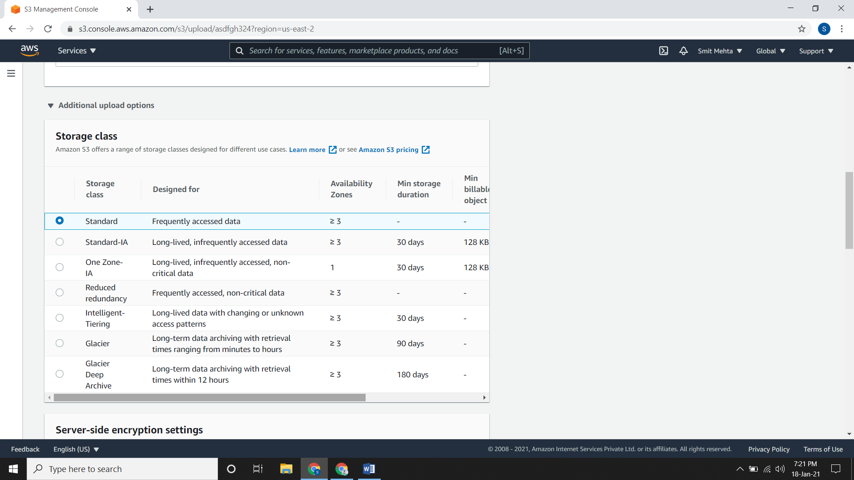

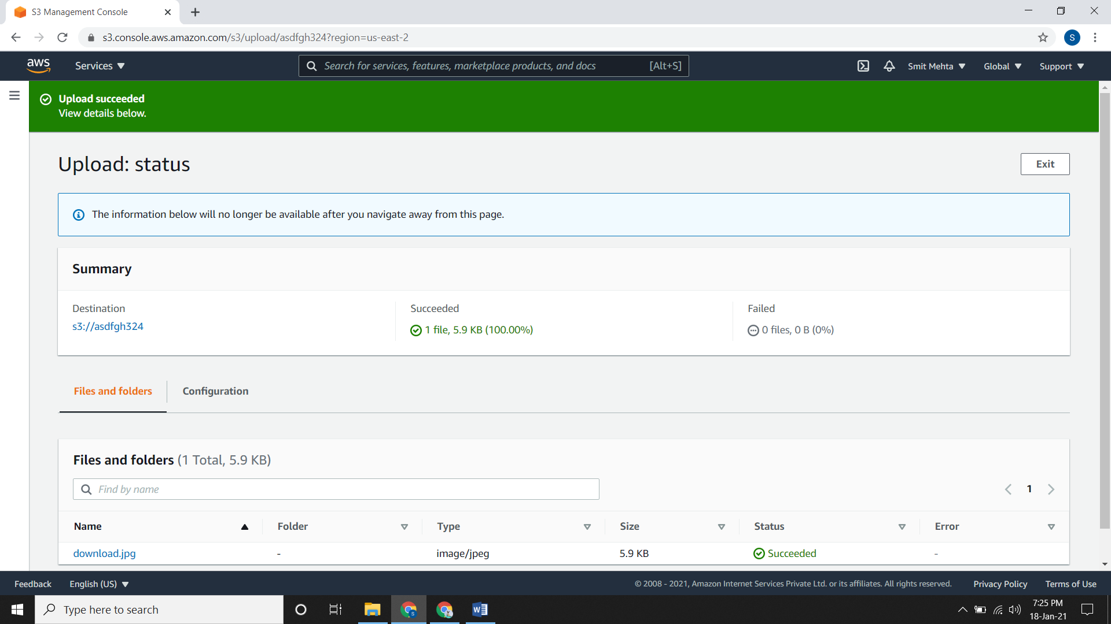

1. **Bucket Policy:**

* Bucket policies provide centralized access control to buckets and objects based on a variety of conditions.
* The policies are expressed in the access policy language and enable centralized management of permissions.
* The permissions attached to a bucket apply to all of the bucket's objects that are owned by the bucket owner account.

1. **AWS Identity and Access Management:**

* AWS IAM is used to manage access over the Amazon S3 resources.
* Here, you can create groups and assign some users to it. You can also give some policies to the group so that each user gets it accordingly.

1. **Access Control Lists (ACL):**

* From here you can control access to each and every bucket and objects inside the bucket using ACL.

**Set ACL permissions for a bucket:**

* Open the bucket and go to **permissions**, scroll down and under **Access Control List (ACL)** click on **Edit.**
* To change bucket owner’s permission, edit the **Bucket owner** permissions.
* To grant or undo permissions for the general public, edit the **Everyone (public access)** permissions.
* To grant or undo permissions for anyone with an AWS account, edit the **Authenticated Users group (anyone with an AWS account)** permissions.
* To grant or undo permissions for Amazon S3 to write server access logs to the bucket, edit the **S3 log delivery group** permissions.
* To access for other AWS accounts, **Add Grantee** and save the changes.

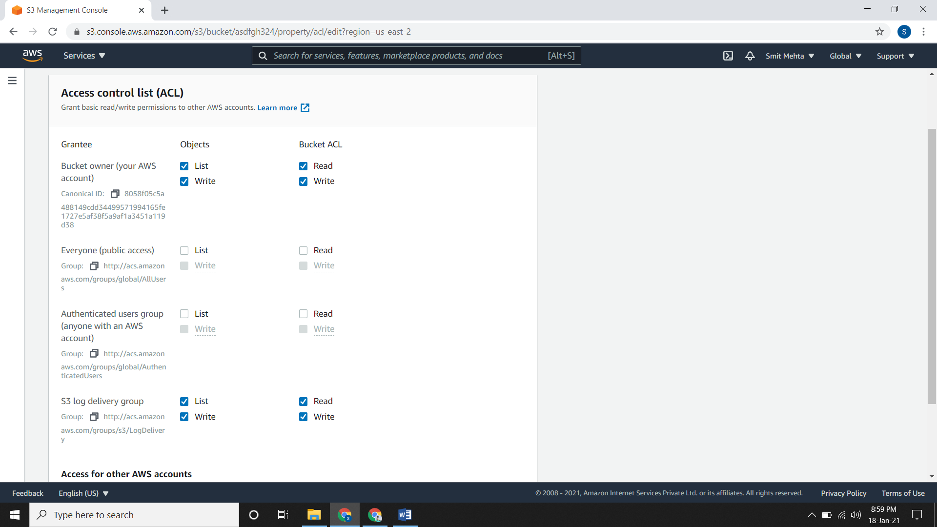

**Set ACL permissions for an object:**

* Open the bucket and click on the object you want to set ACL permissions and then go to **permissions**, under **Access Control List (ACL)** click on **Edit.**
* For editing this you need to disable the bucket policies first.

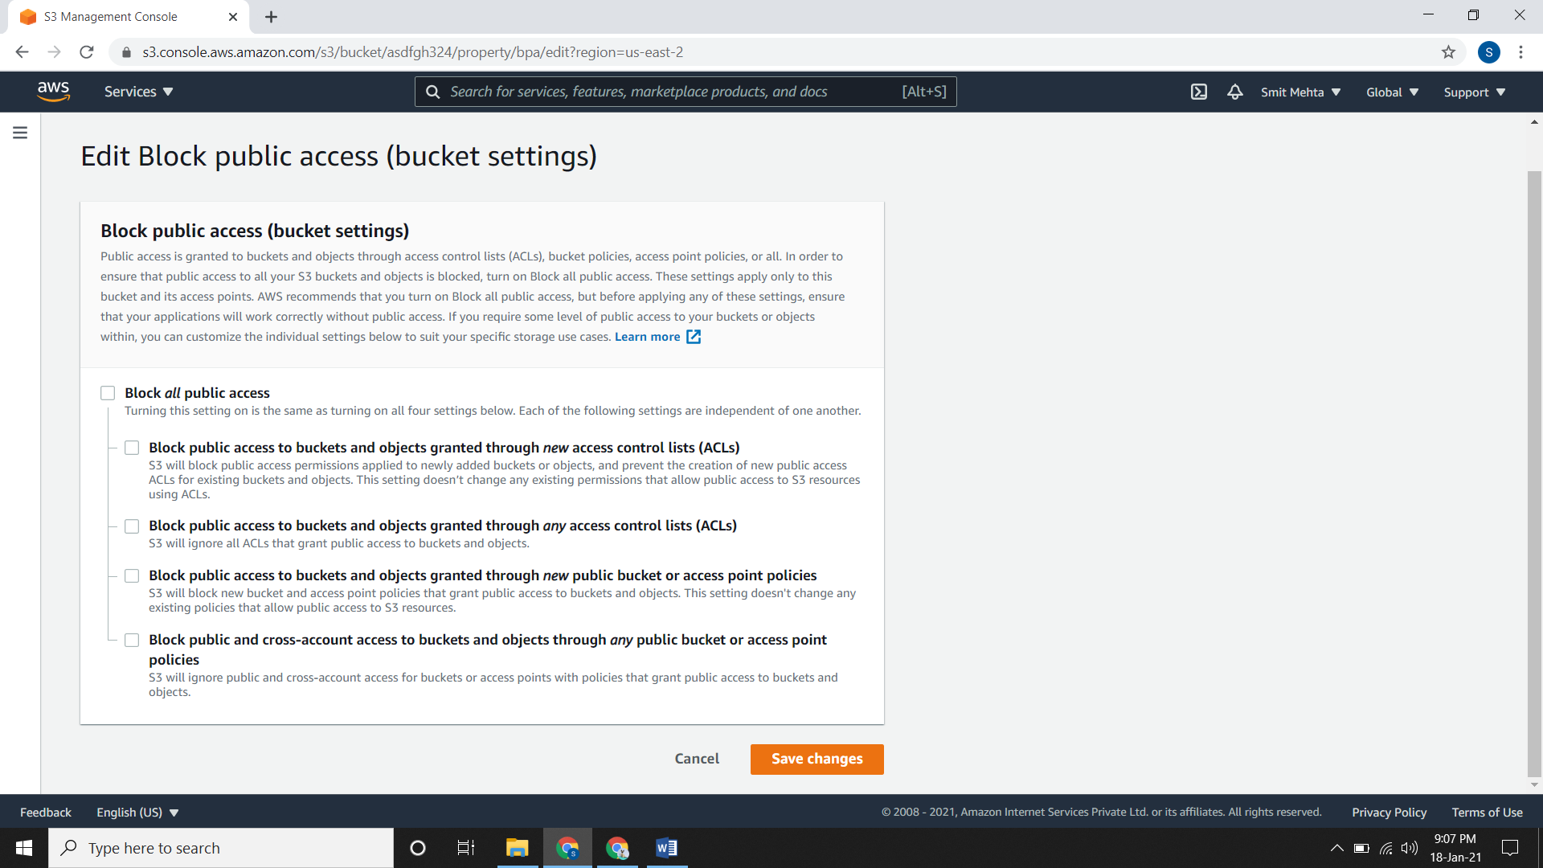

* To change object owner permission, edit **Object owner (your AWS account)** permissions.
* To grant or undo permissions for the general public, edit the **Everyone (public access)** permissions.
* To grant or undo permissions for anyone with an AWS account, edit the **Authenticated Users group (anyone with an AWS account)** permissions.
* To access for other AWS accounts, **Add Grantee** and save the changes.

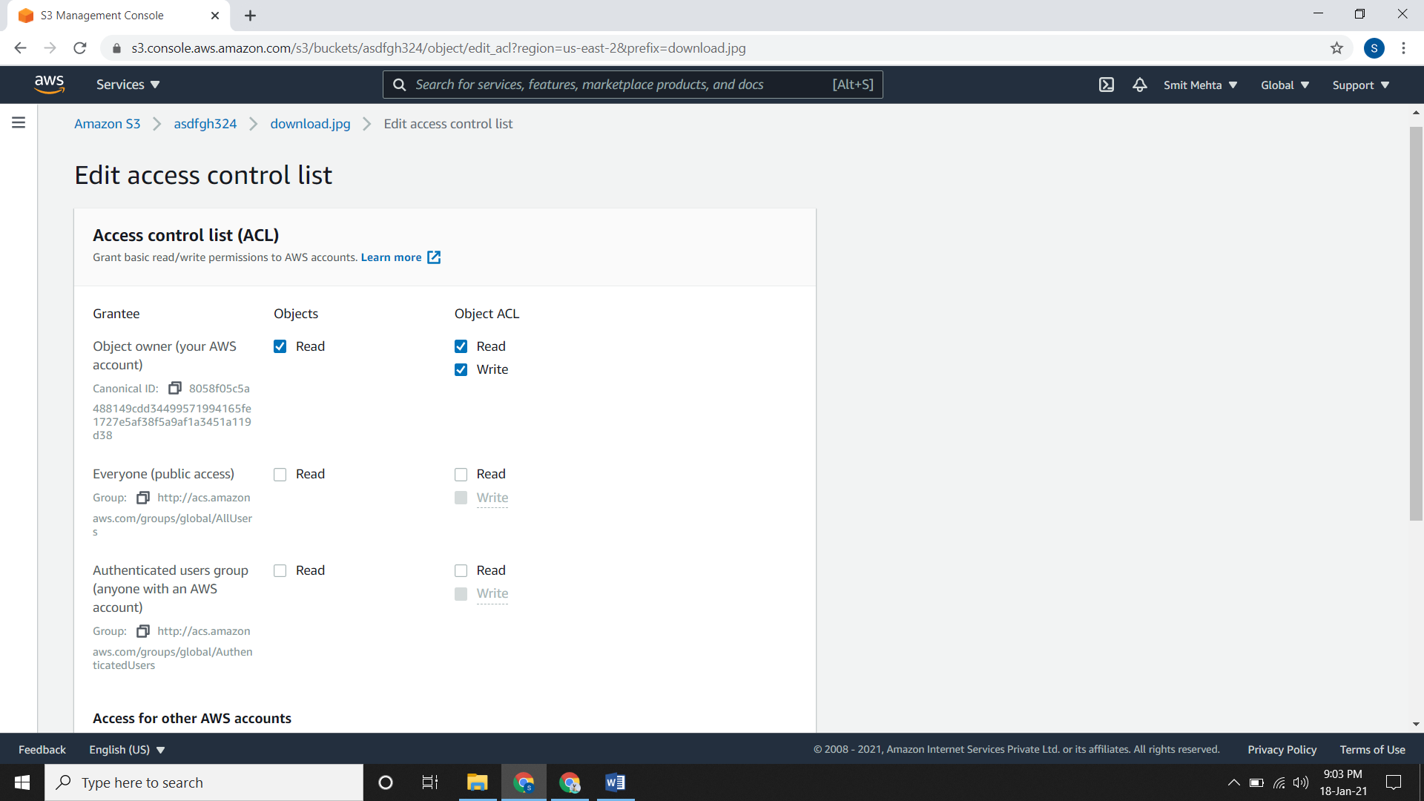

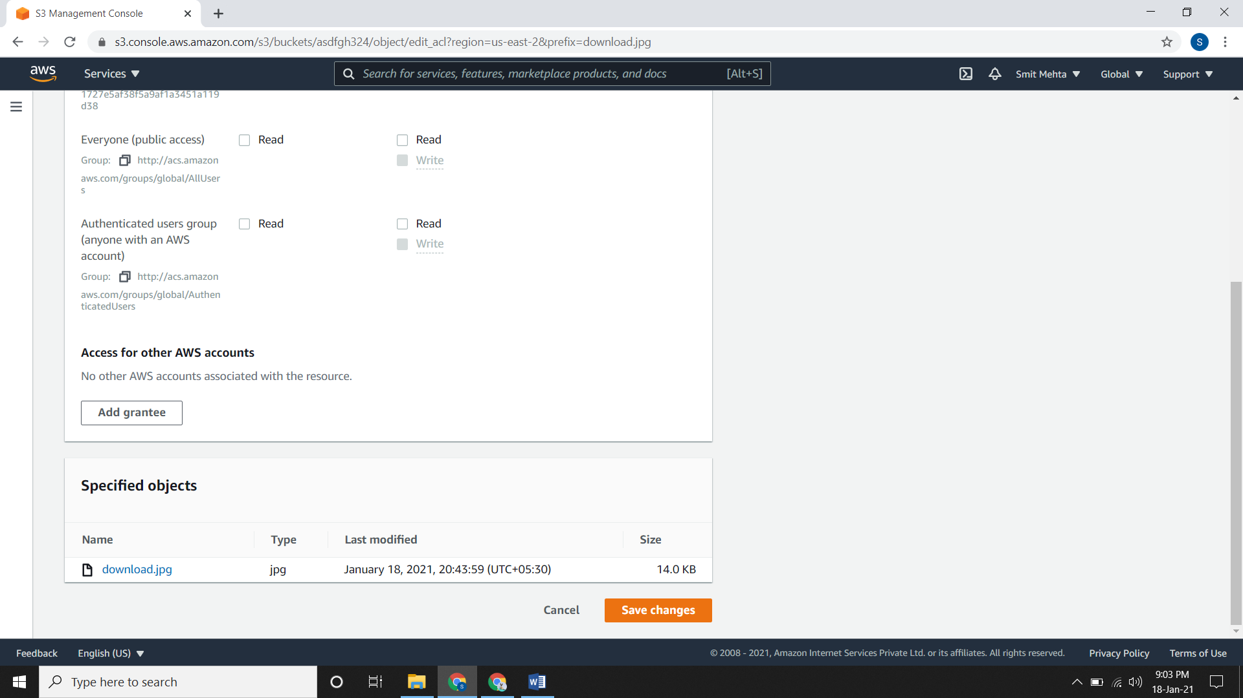

1. **Versioning:**

* It is keeping multiple variants/versions of an object in the same bucket.

**Enabling Versioning on buckets:**

* Go to the bucket, open it and go to **properties**.
* Under **Bucket Versioning,** click on **Edit** and now **Enable/Suspend** it accordingly and save the changes.

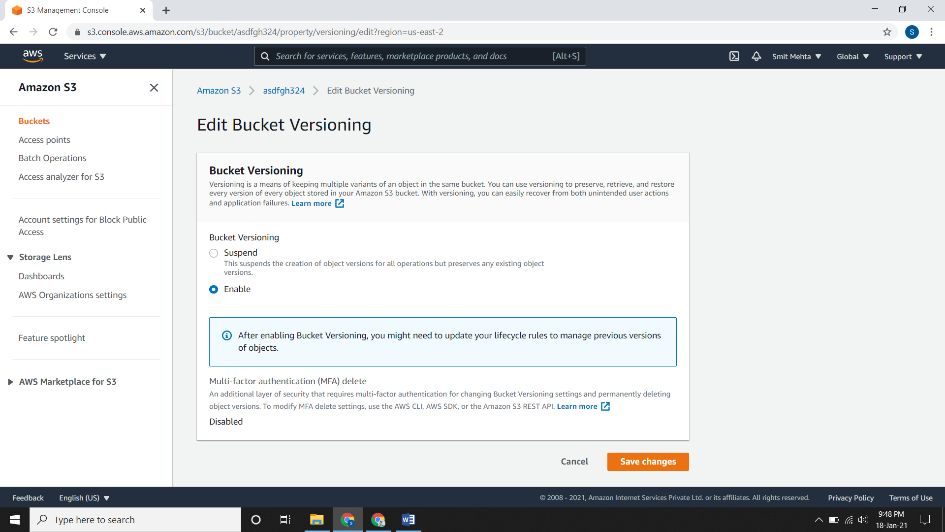

**Adding objects to versioning-enabled buckets:**

* It is same as uploading objects in bucket.

**Listing objects in a versioning-enabled bucket:**

* Go to the bucket, choose the bucket name and open it.
* Now select the **List Versions** switch.

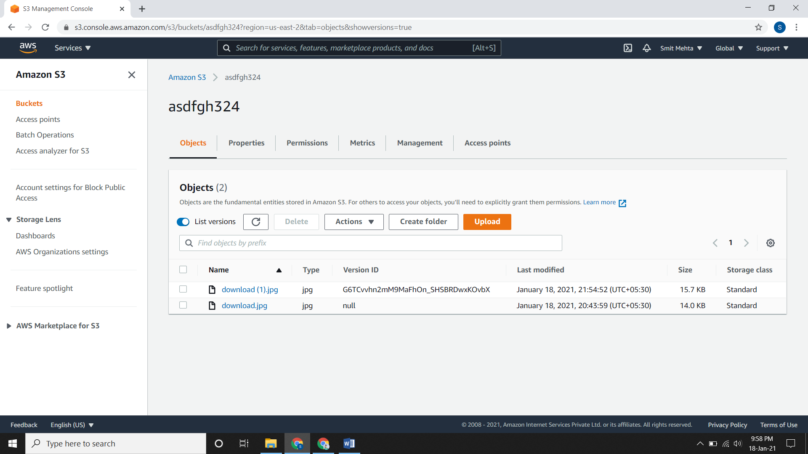

**Retrieving object versions from a versioning-enabled bucket:**

* Go to the **bucket**, open it and go to **object** lists.
* Choose the **Versions**, select the file and go to **actions** and **download** it.

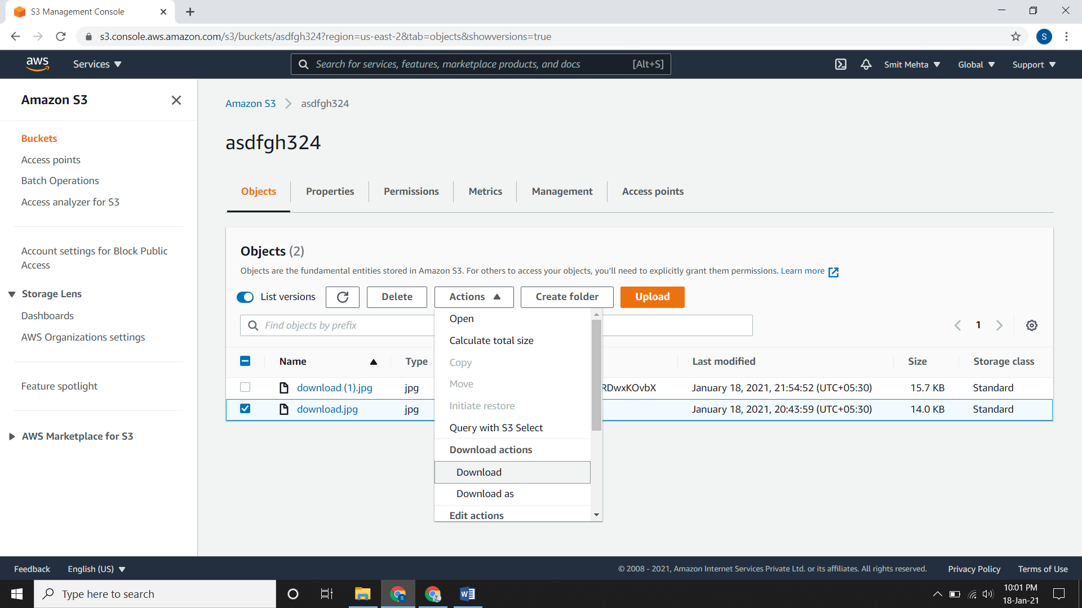

**Deleting object versions from a versioning-enabled bucket:**

* Go to the **bucket**, open it and go to **object** lists.
* Choose the **Versions**, select the file and click on **delete.**

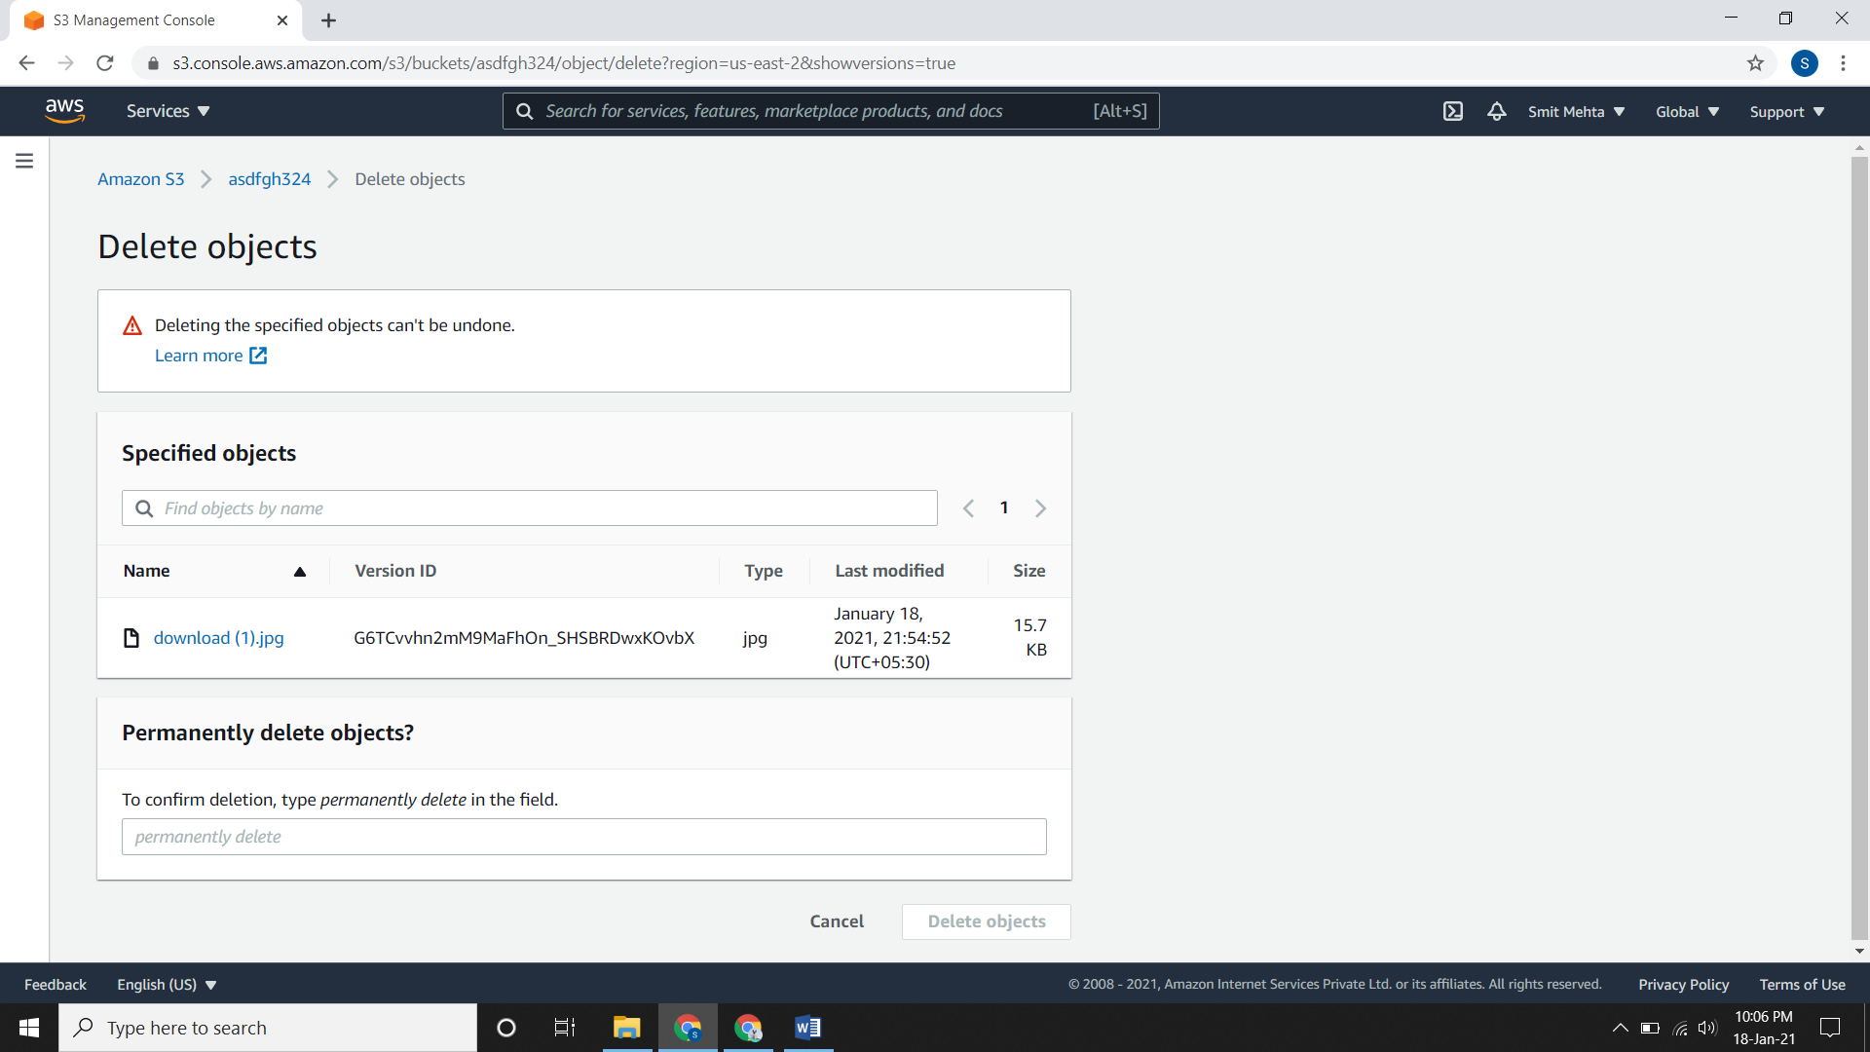

* After writing **permanently delete** click on **delete object.**

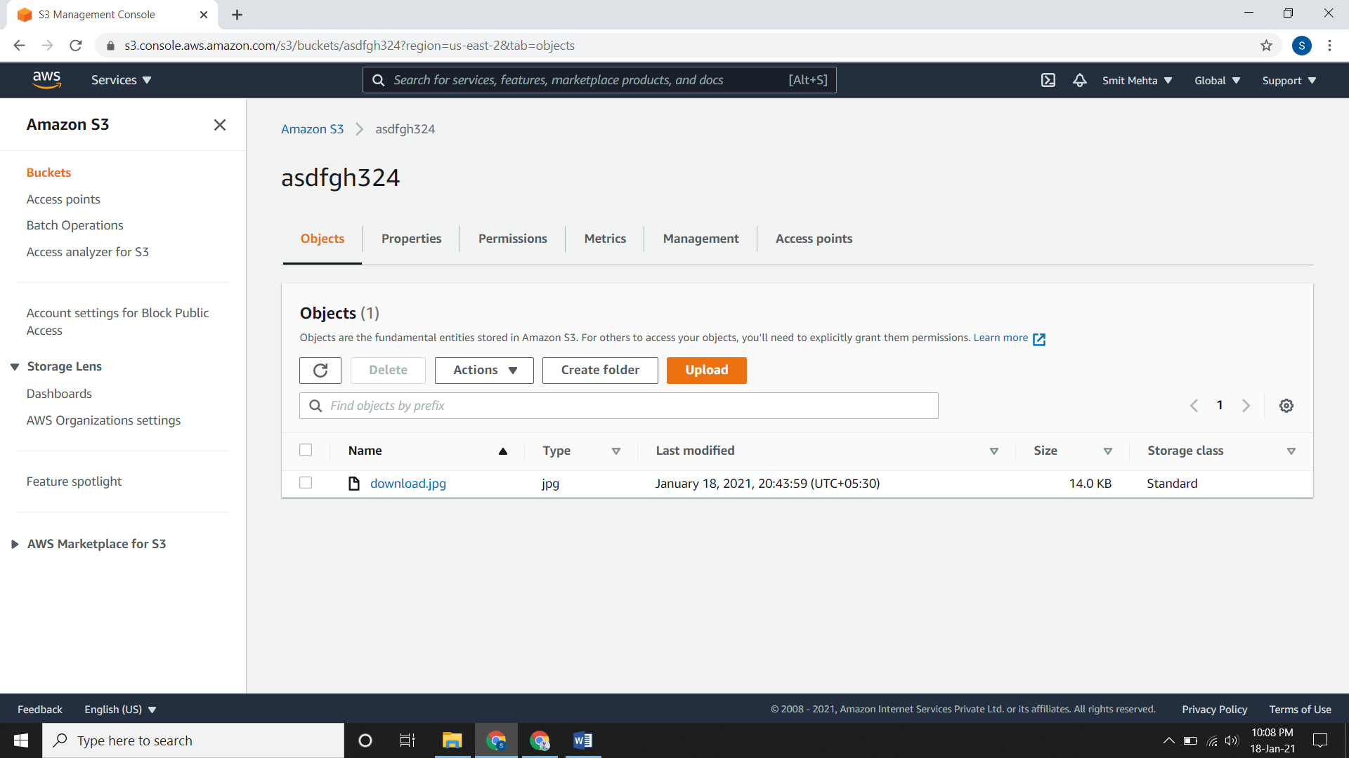

**Amazon S3 Block Public Access:**

* This feature provides settings for access points, buckets, and accounts to help you manage public access to Amazon S3 resources.
* There are 4 different types of block public access where you can block any of them at a single time. You can block all of them at a single time too.
* The 4 types are:

1. Block public access to buckets and objects granted through **new access control lists (ACLs)**
2. Block public access to buckets and objects granted through **any access control lists (ACLs)**
3. Block public access to buckets and objects granted through **new public bucket or access point policies**
4. Block public and cross-account access to buckets and objects through **any public bucket or access point policies.**

* So if you have enabled(ON) the block public access you can’t open the object file through its URL.
* Open the **bucket**, go to the object file, go to **properties** and open the **Object URL**
* You will see this error because you have restricted/blocked the public access.

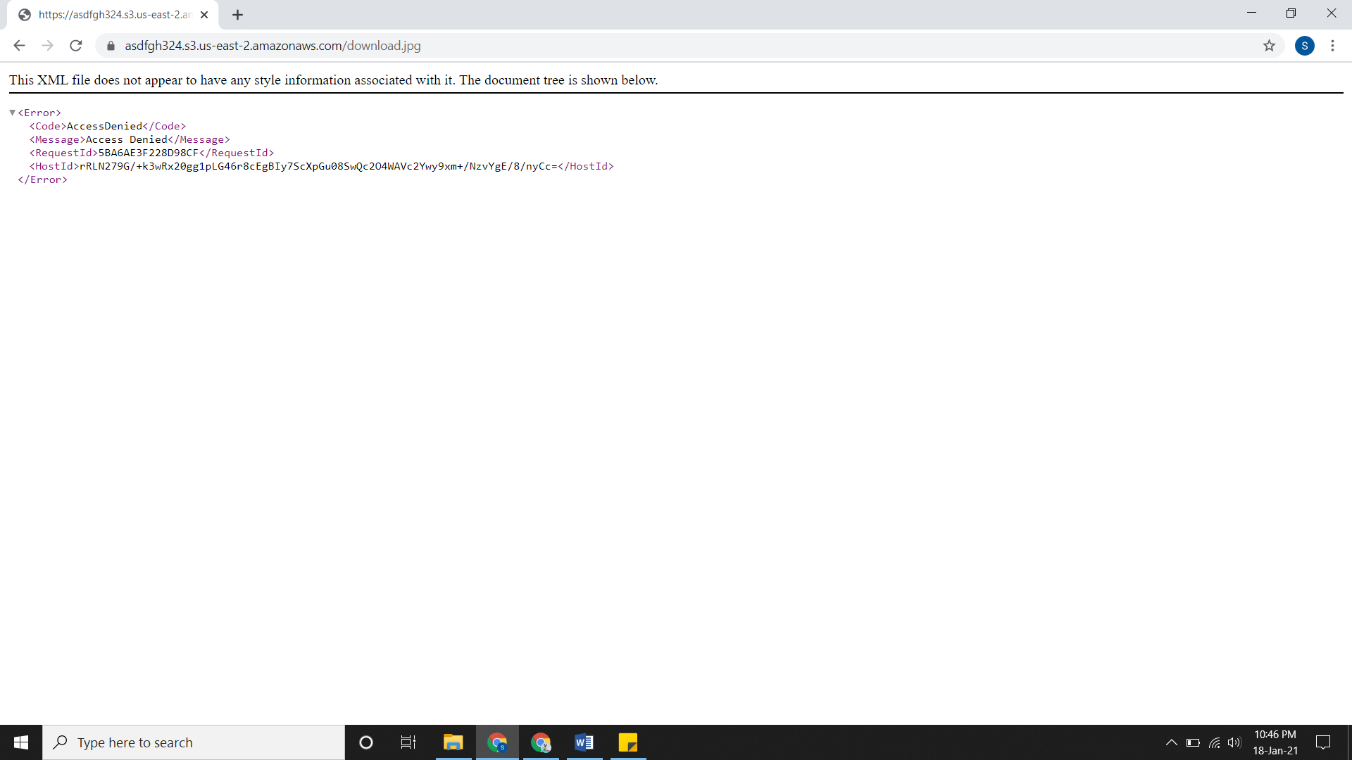

* To open this file in public we need to disable the block public access and give some bucket policy. For that
* Go to the bucket, open it and go to **permissions.**
* Edit the **block public access (bucket settings)**, just make is disable/OFF and save it.
* As you save it, just type **confirm** in the text box and confirm it.
* Now you also need to edit the **bucket** **policy** too.
* After editing the bucket policy, it will be shown that your bucket is **Publicly Accessible** in red colour.

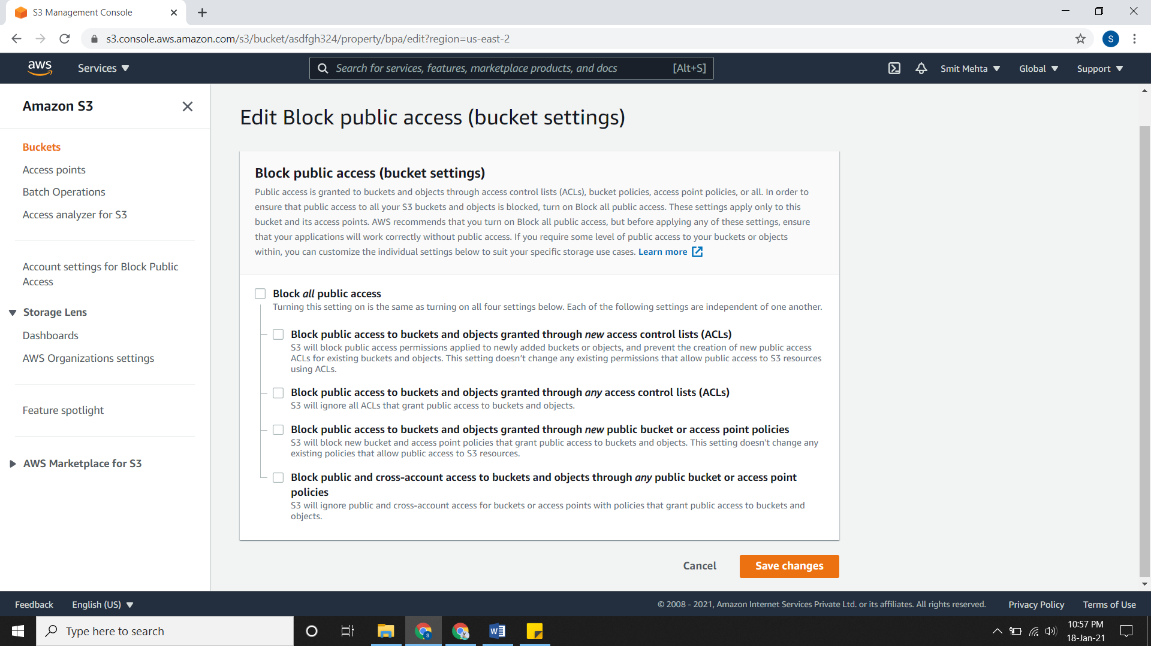

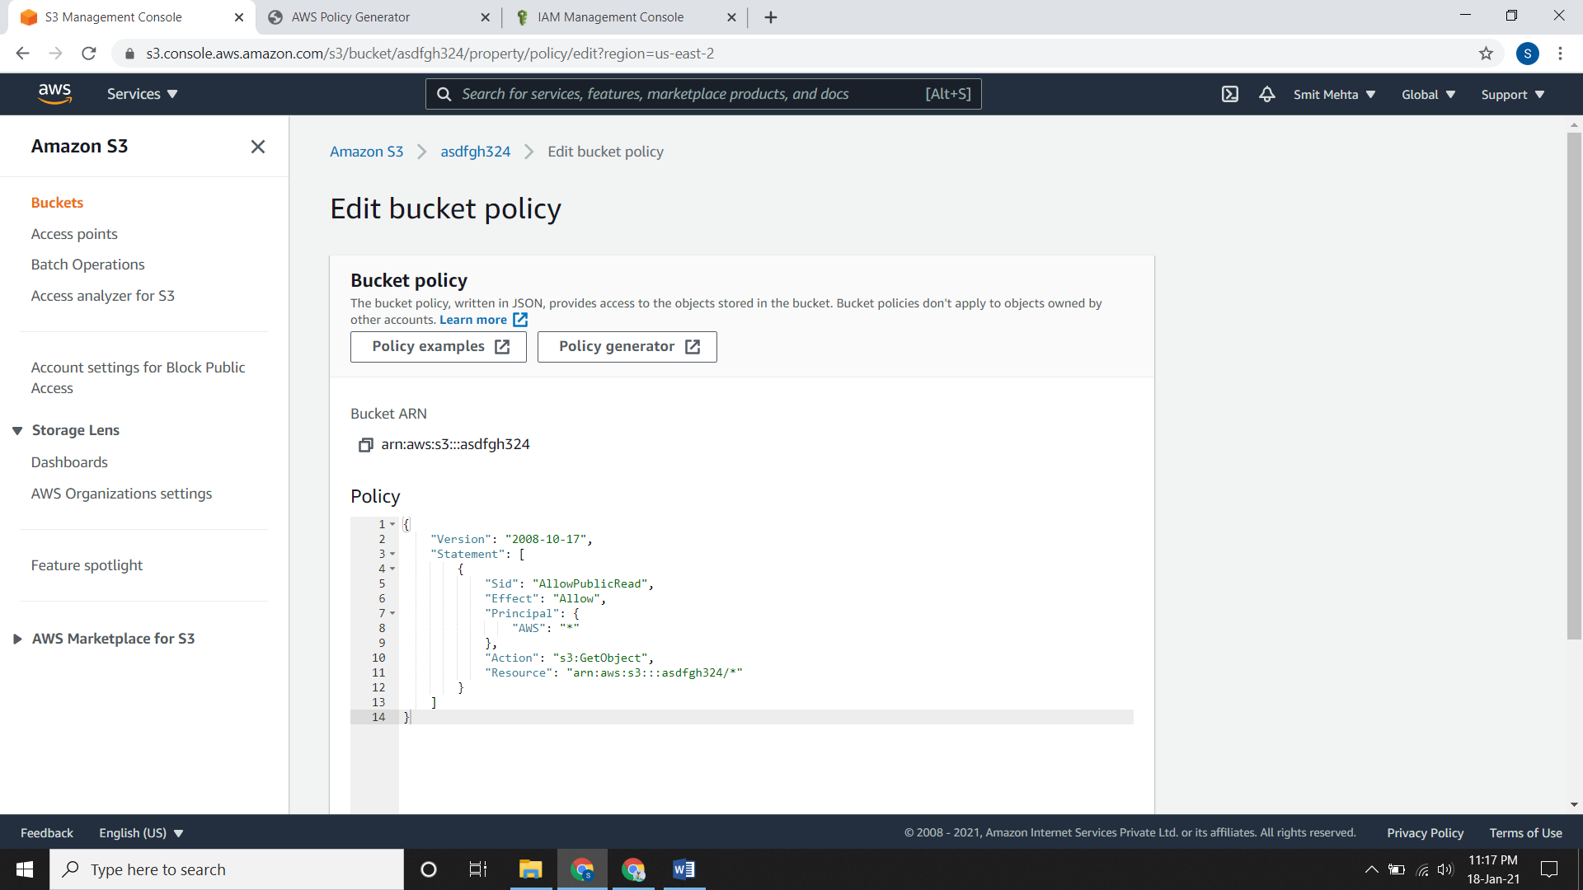

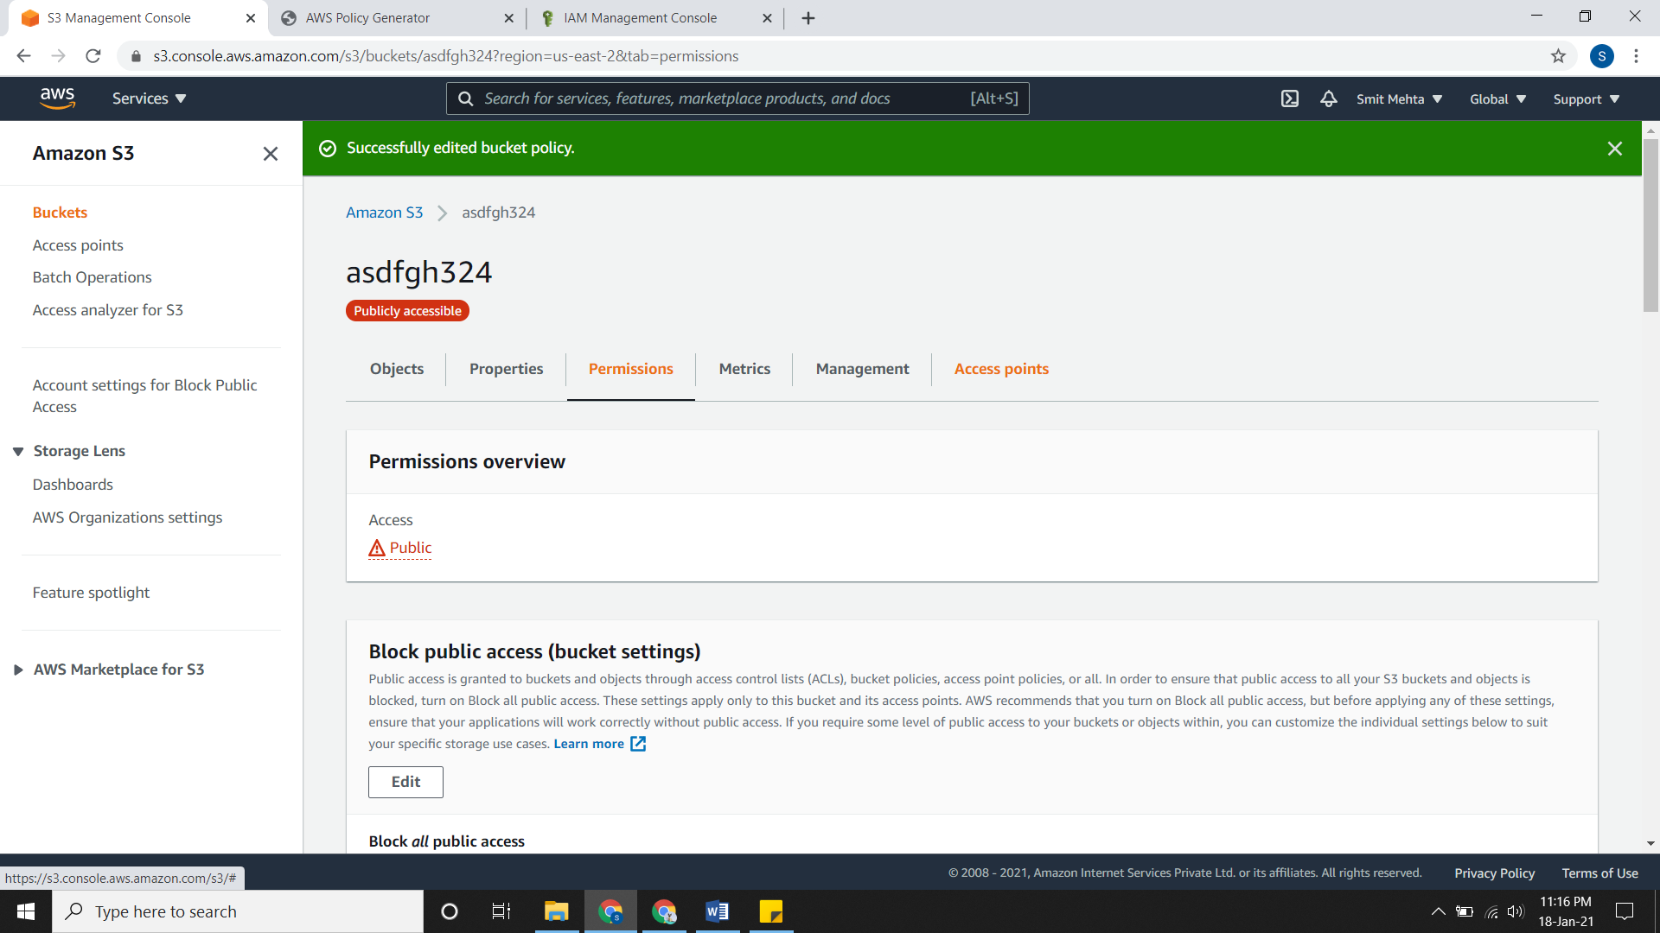

* Now we can open the URL link.

**Bucket Policy**

* A bucket policy is an AWS IAM policy that uses JSON based access policy language.
* Some of the elements of a policy are:

1. **Resource**: To identify a resource we use (ARN) Amazon Resource Name of the bucket/object/access point or jobs.
2. **Actions**: It contain the operations you need to perform.
3. **Effect**: After the above action is perform what effect is to be performed is decided here. The effect can be **Allow or Deny.**
4. **Principal:** In this section, it will be for the recipient of the permission of the user, account, service or any other entity. Generally, it is the account number or ARN of IAM user.
5. **Condition:** Conditions for when a policy is in effect.

* For ex., if you check the policy of **AmazonElasticMapReducePlacementGroupPolicy**

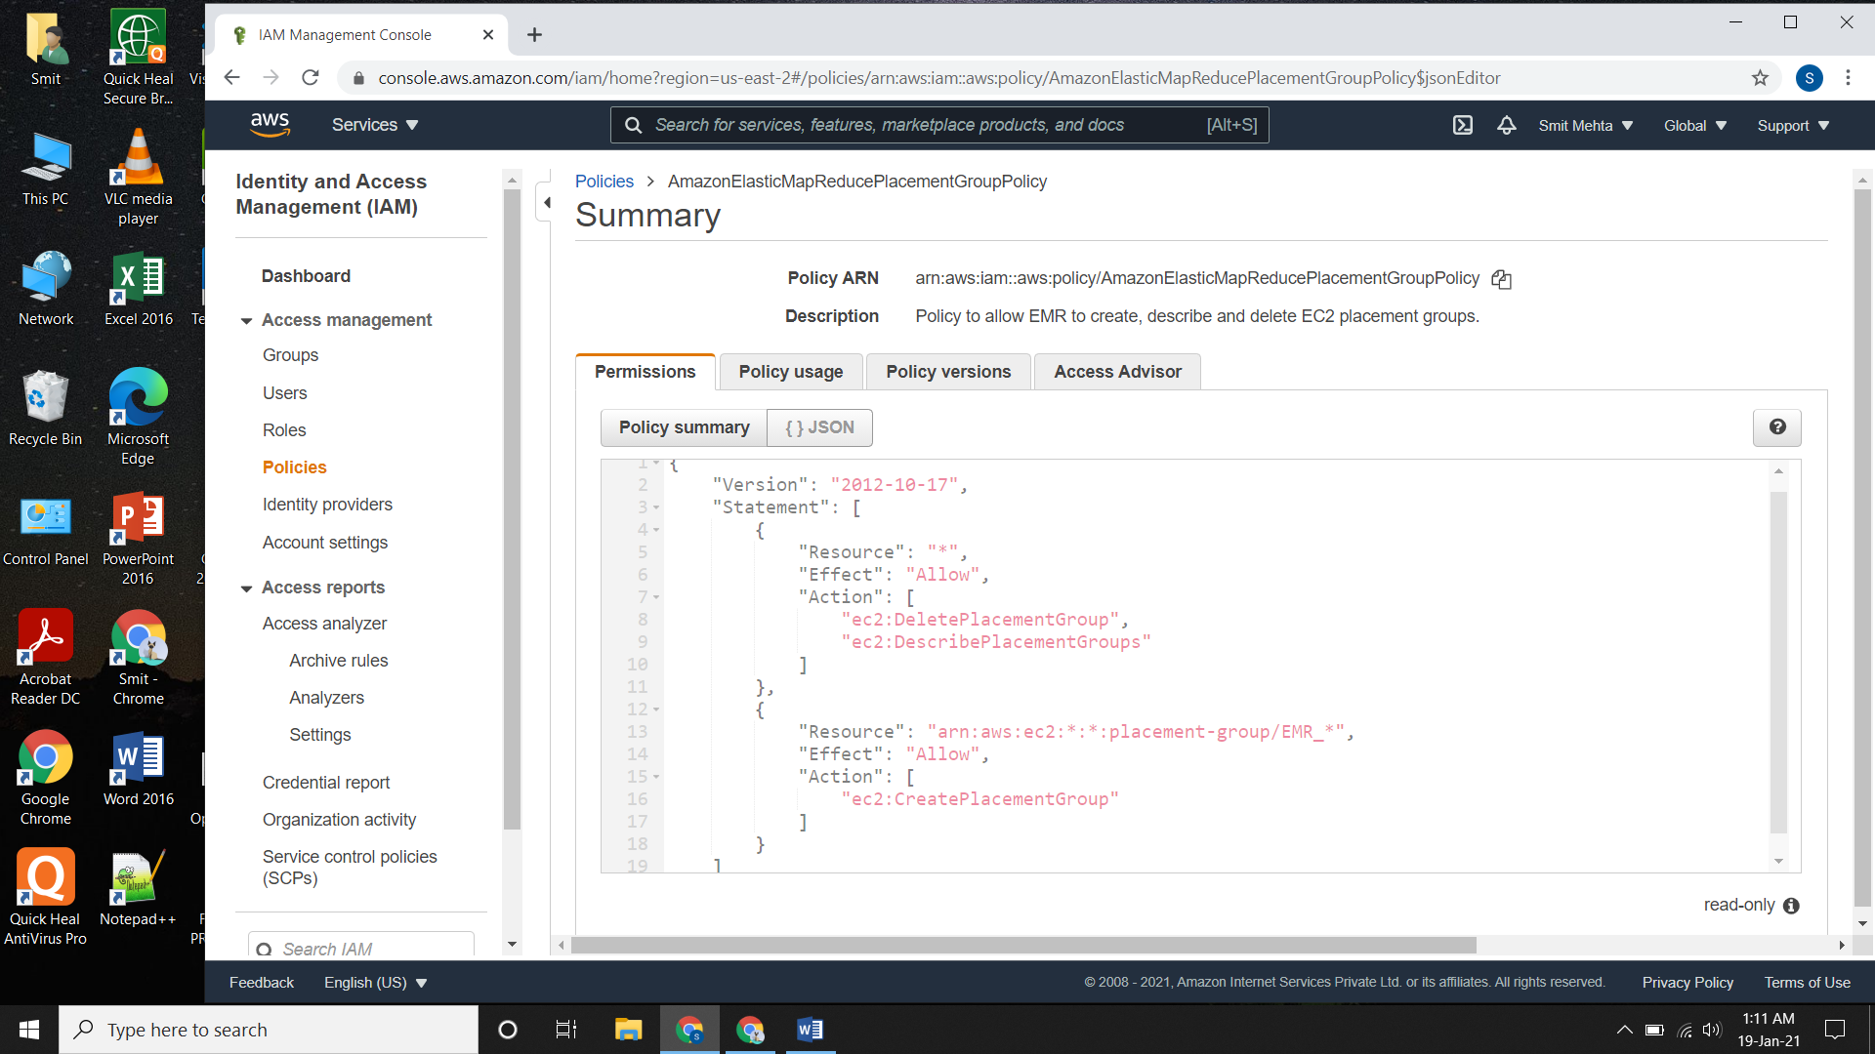

* In the first part of Statement, **Resource** is **\*** i.e. for everything. Here for **Allow effect** there are 2 actions given. One is for **ec2 delete placement group** and another is for **ec2 describe placement groups.**
* In the second part of Statement, **Resource** is for **EC2** **EMR placement group.** Here for **Allow effect** the action is to **create ec2 placement group.**

**Generating Policies:**

* Go to IAM, click on policy and create policy.
* Choose a **Service** which you want to choose like EC2, S3, EFS, etc.
* Choose some **actions** for that service.
* For **Resources** choose resources as Specific or All resources.
* In **Request Conditions,** you need to choose a MFA or source IP but it is optional.
* Review the policy, give a name and description and create it

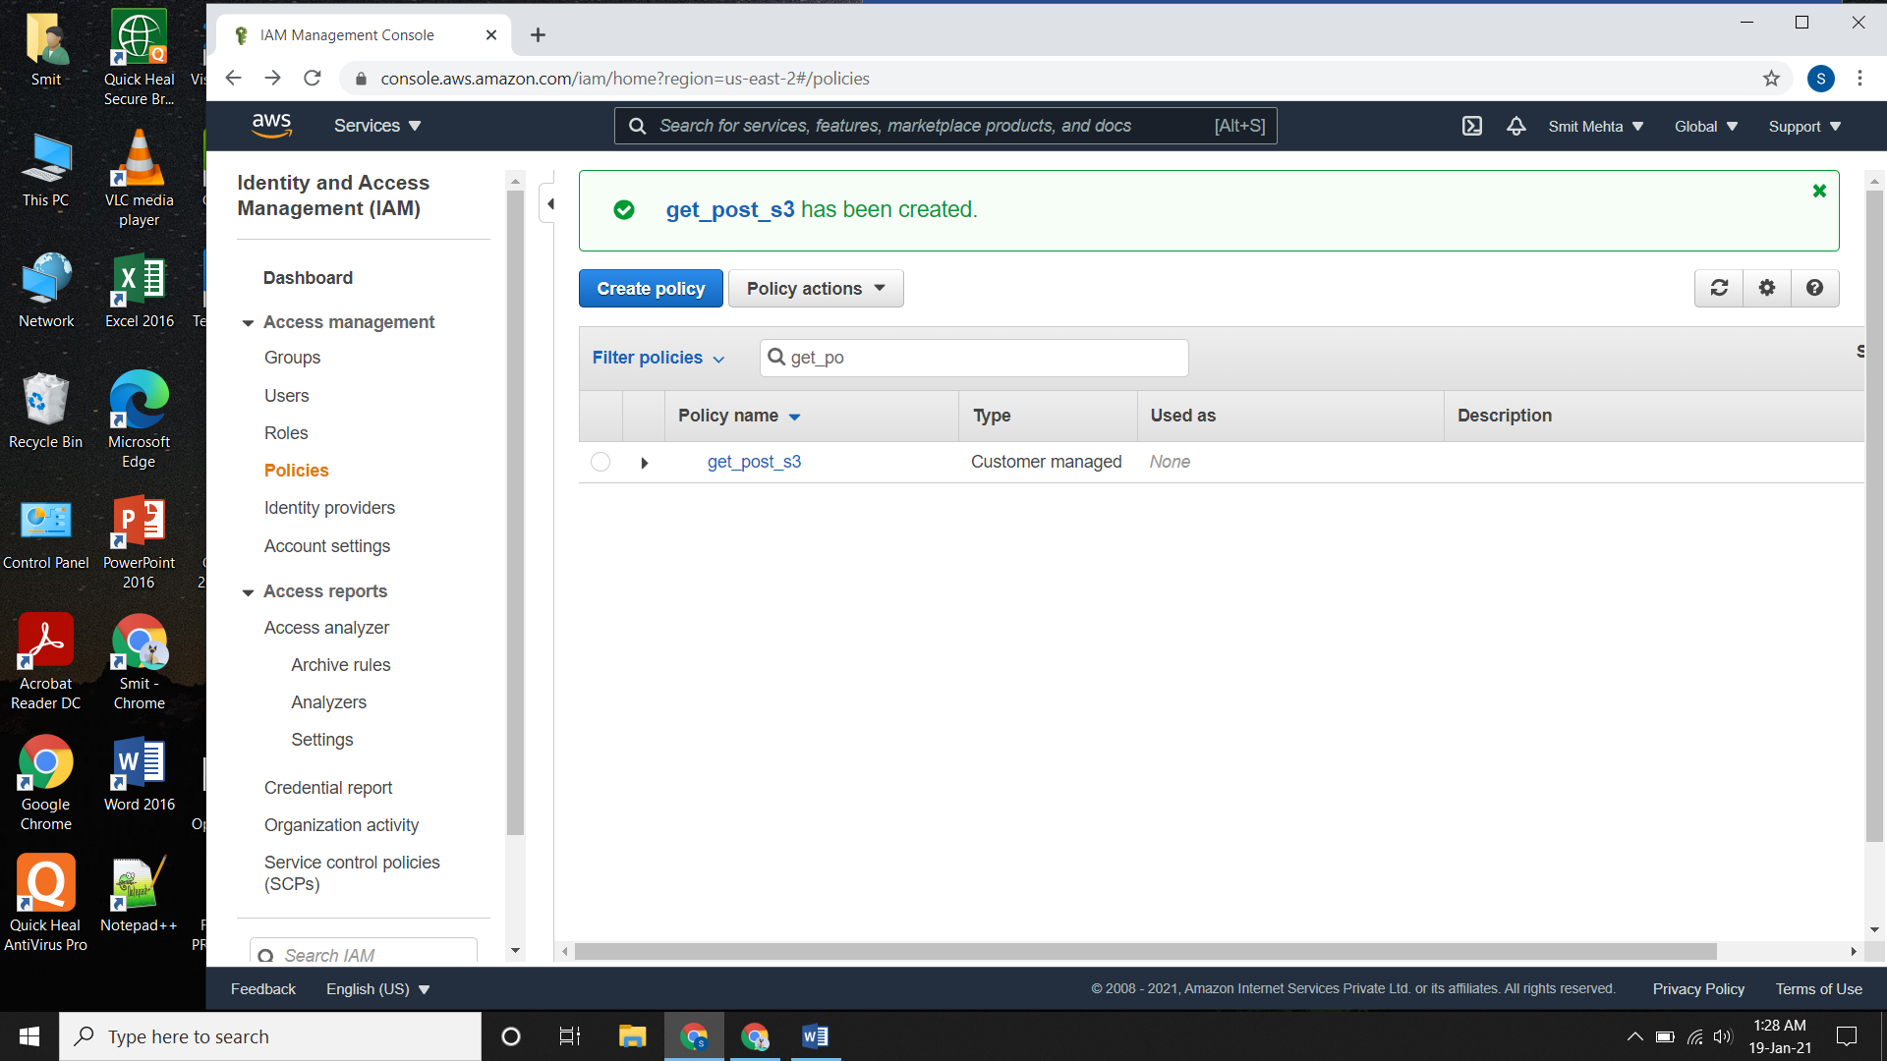

* If you want to generate bucket policy for S3 you can generate it.
* Go to bucket, click on it, go to permissions and edit it.
* Click on the Policy generator.
* Select the Type of Policy, choose the **effect** and add a **Principal** to it.
* Give the necessary **actions** and the **ARN** of the bucket.
* Click on **Add Statement** and **Generate the Policy**
* Now copy the policy an paste it in the bucket policy area and save the change.

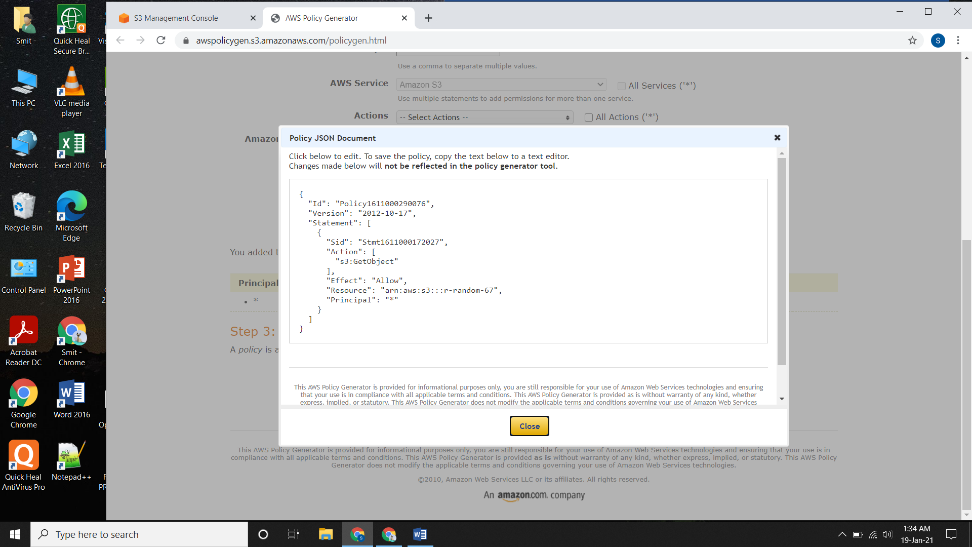

**Bucket Replication:**

* It’s just a way to automatically have the contents of one bucket to be replicated in the other bucket. There are 2 types of object replication

1. **Cross-Region Replication (CRR):** To copy objects in different AWS region.
2. **Same-Region Replication (SRR):** To copy objects in same AWS region.

* Some of the advantages of replication are:

1. It makes copies of your objects that retain all metadata, such as the original object.
2. You can replicate data according to your storage class and change it.
3. You can set multiple buckets across different regions.

* Firstly, create a bucket, open it and go to **Management.**
* Scroll down and **create replication rule.**
* You need to see if the bucket **Versioning** is enabled or not, if not **enable** it and give a **name**.
* Under **Destination** select the bucket accordingly to your requirement.
* Under **IAM role** click it and add a new one.
* Select the **Encryption, Destination Storage class and additional replication options** according to you as they are optional and save it.

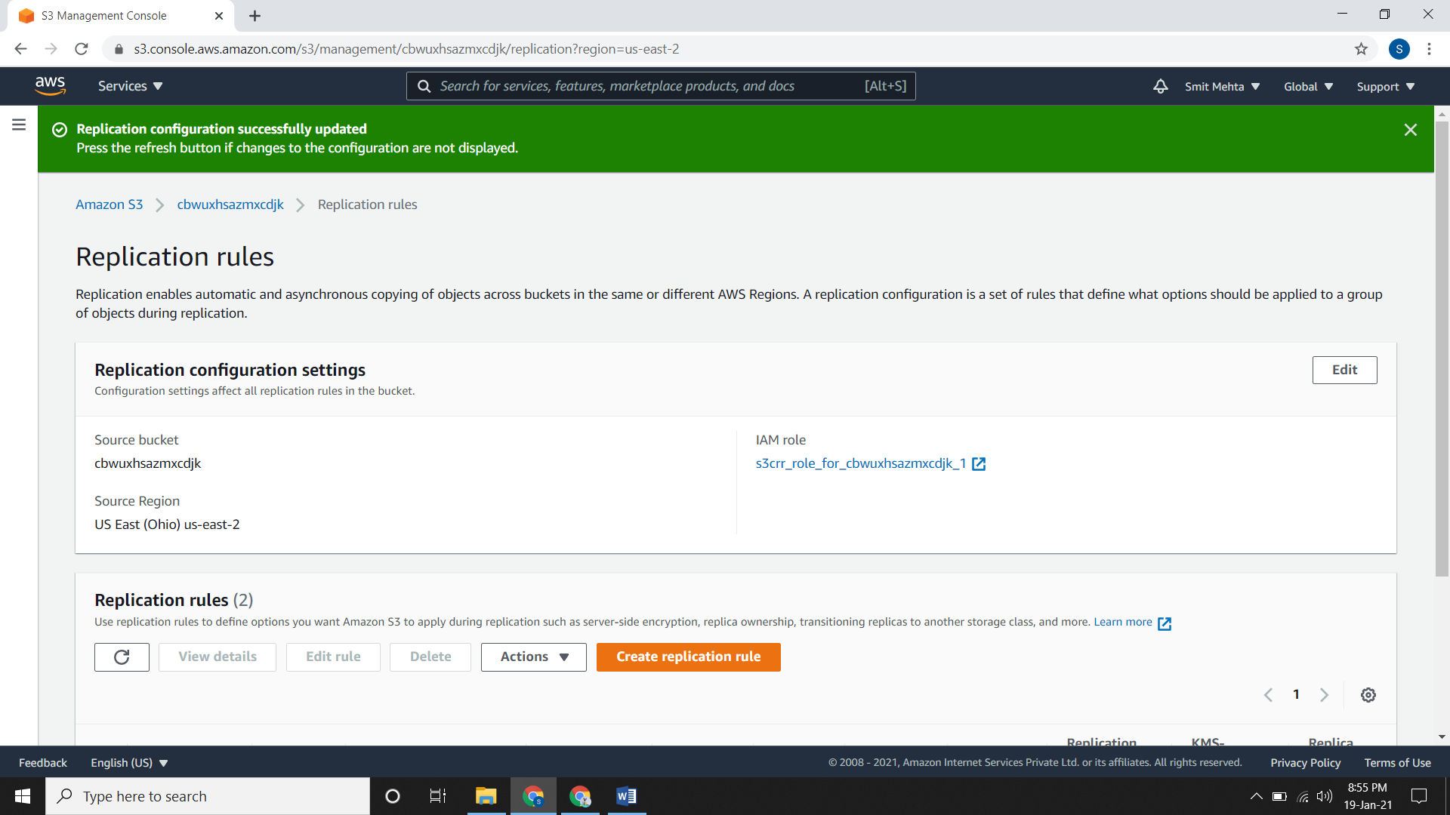

* Now add some files in the source bucket.

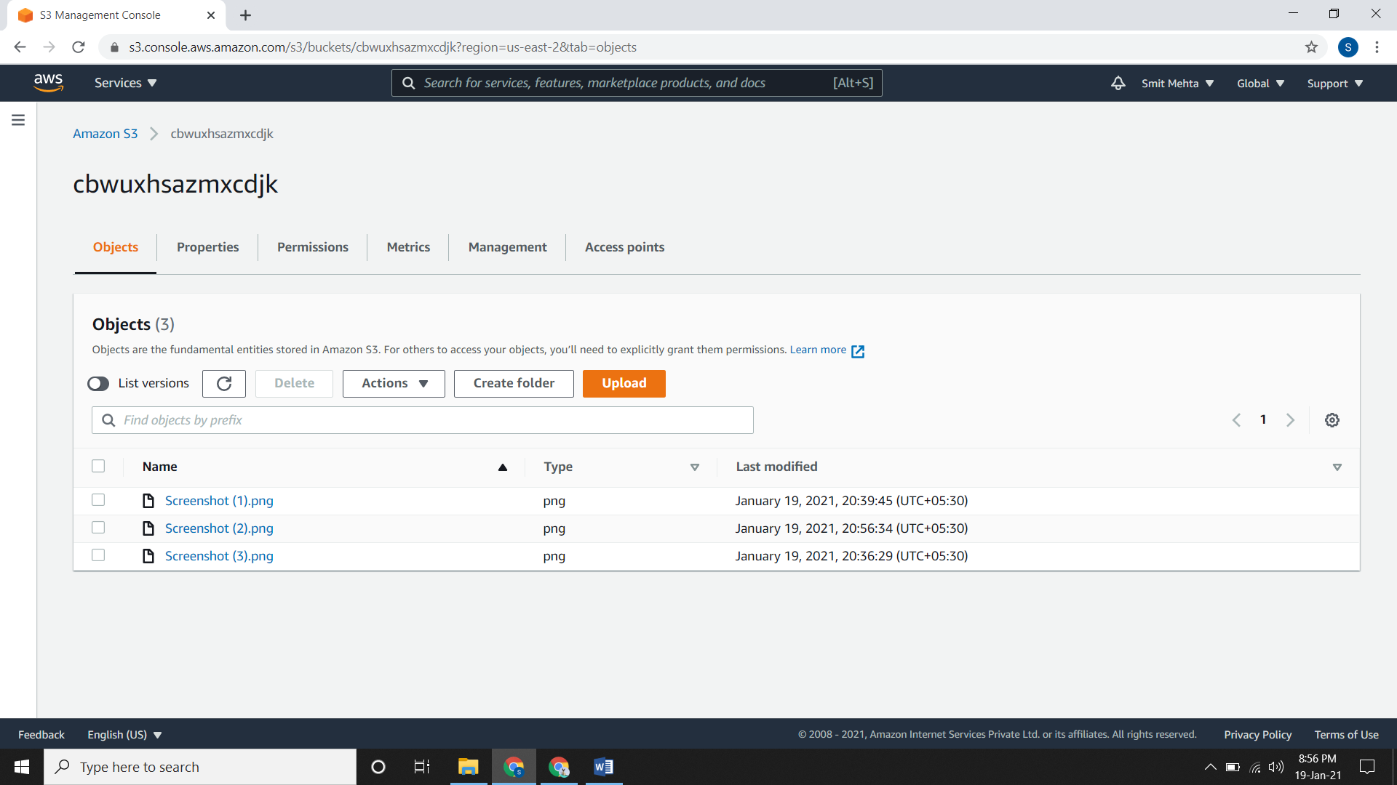

* Now check the destination bucket and after some time you will see these files over there.

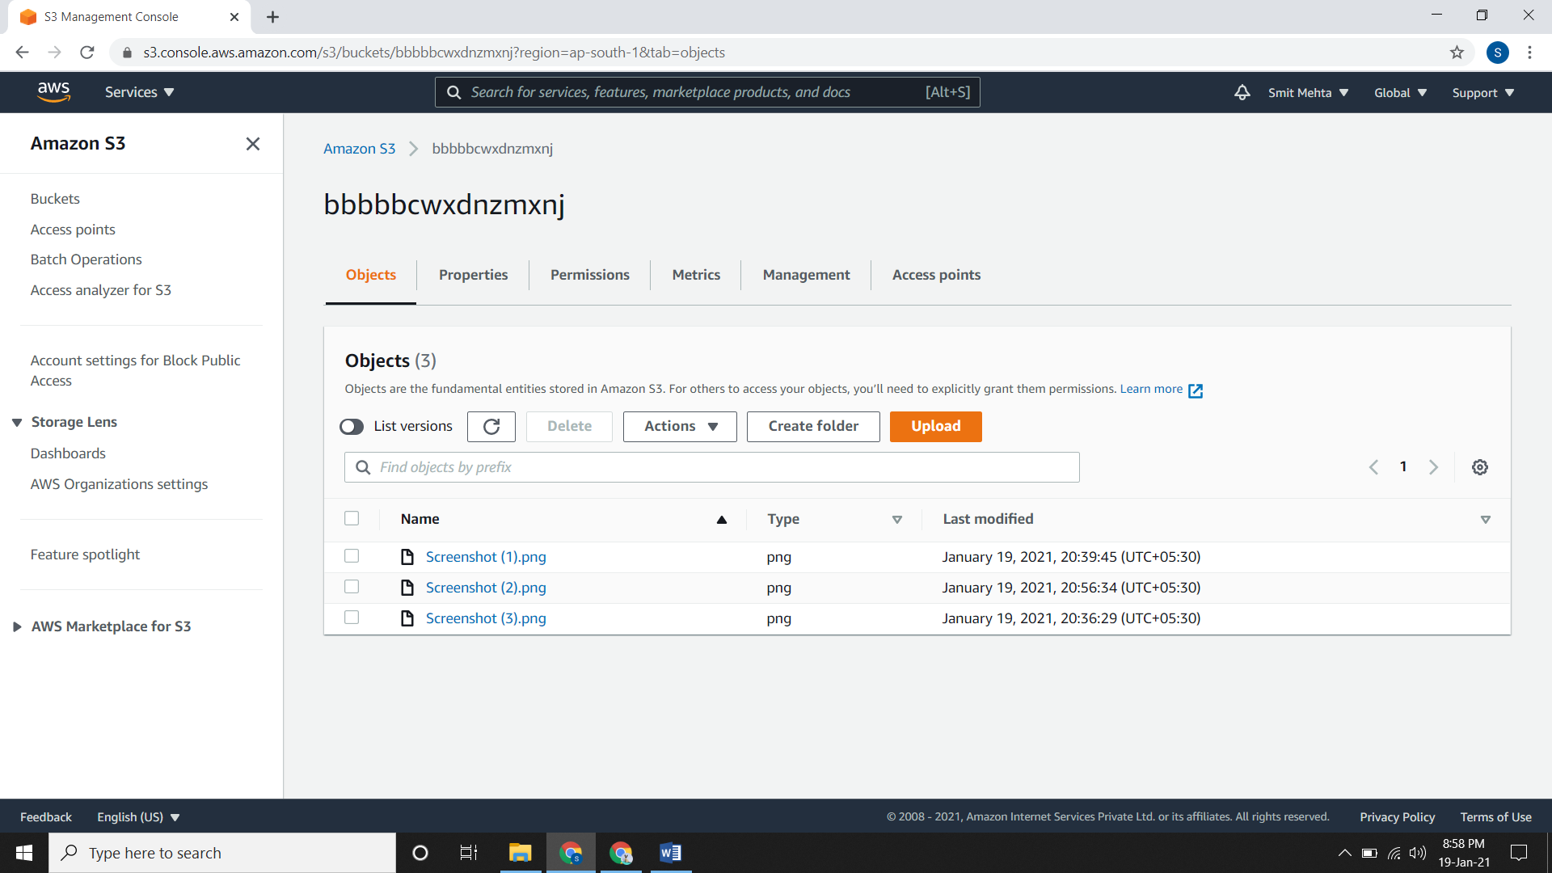

* Suppose you delete some objects from the source file.

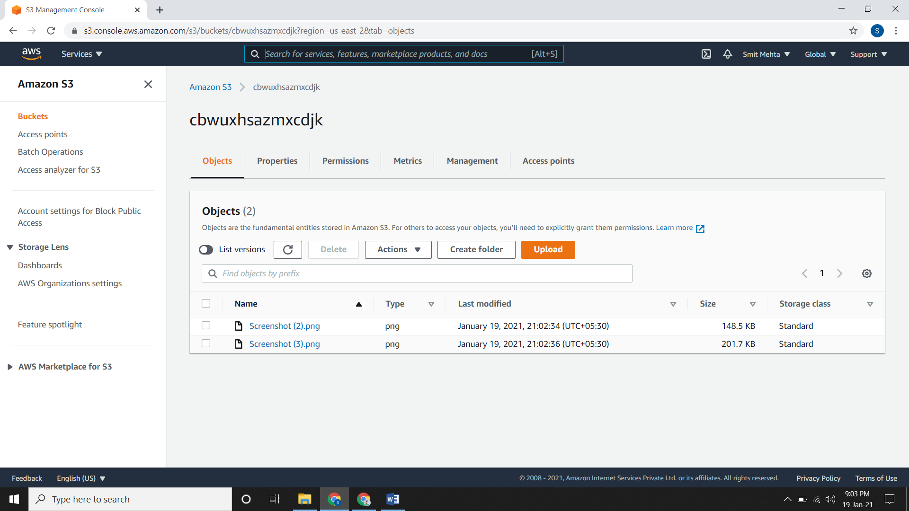

* Now if you check the **List version** section, you will see a **Delete Marker** at that object.

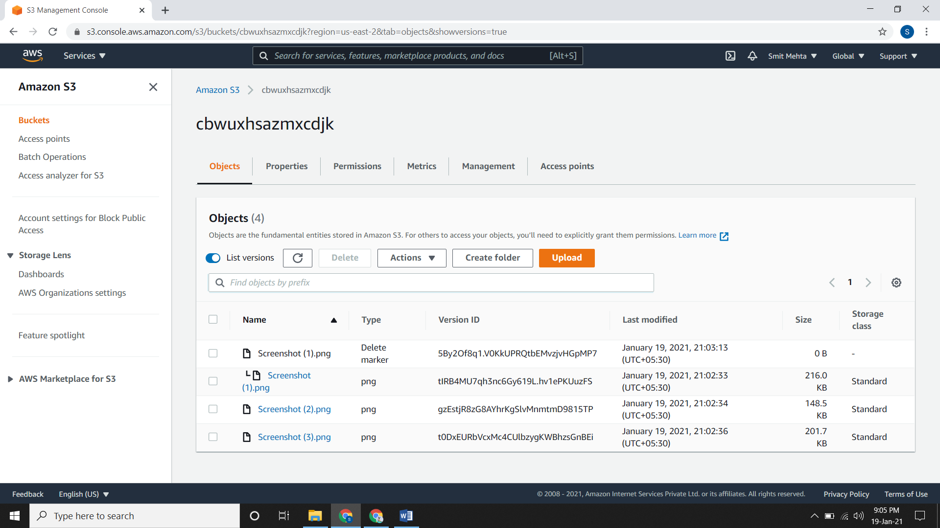

* If you check the destination bucket there will be no change.
* But if you add the same file again in the source bucket and then check the **List version** section in the destination bucket you will see that duplicated object.

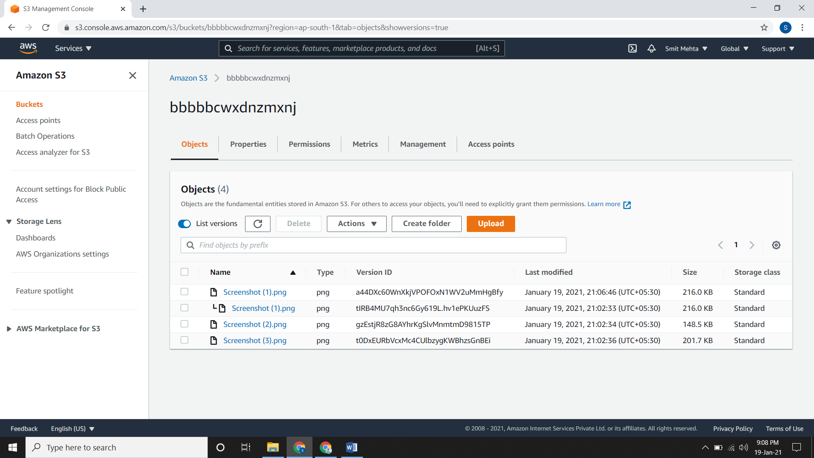

* For deleting the replication bucket, first delete the destination bucket and then the source bucket. Delete the policy and role as well.